**Biorefrigerator Security System**

Biomedical Engineering Senior Design

Dr. Aijun Wang

Progress Report 4

Spring 2024

Team 1

Brayden Chipman - 6/5/24 9:02 PM

Miguel Cruz - 6/5/24 8:51 PM

Ashwin Halepet - 6/5/24 9:41 PM

Vance Padilla - 6/5/24 2:05 PM

**Table of Contents**

**Executive Summary 1**

Problem 1

Objective 3

Design Solution 3

Assessment of Design Goals 3

Value Impact 6

Future Work and Improvements 7

**Client Report 8**

Instructions for Manufacturing 9

Instructions for Assembly 11

Instruction for Use 13

Installation 13

Use of the PIN Pad 14

Changing the Battery 15

Safety Precautions 15

Recognized Consensus Standards 15

Verification and Validation Protocol 16

Component Verification Tests 18

Subsystem Device Verification 22

Full Assembly Verification 23

Verification and Validation Results 24

Results Analysis 26

Final Bill of Materials 27

Final Engineering Drawings 29

**References 37**

**Appendix 39**

Figure 15: Exploded View of the Biorefrigerator Security System 39

Figure 16: House of Quality 40

Table 8: Complete Failure Modes and Effects Analysis 44

# Executive Summary

Figure 1: Introductory Figure for the Design

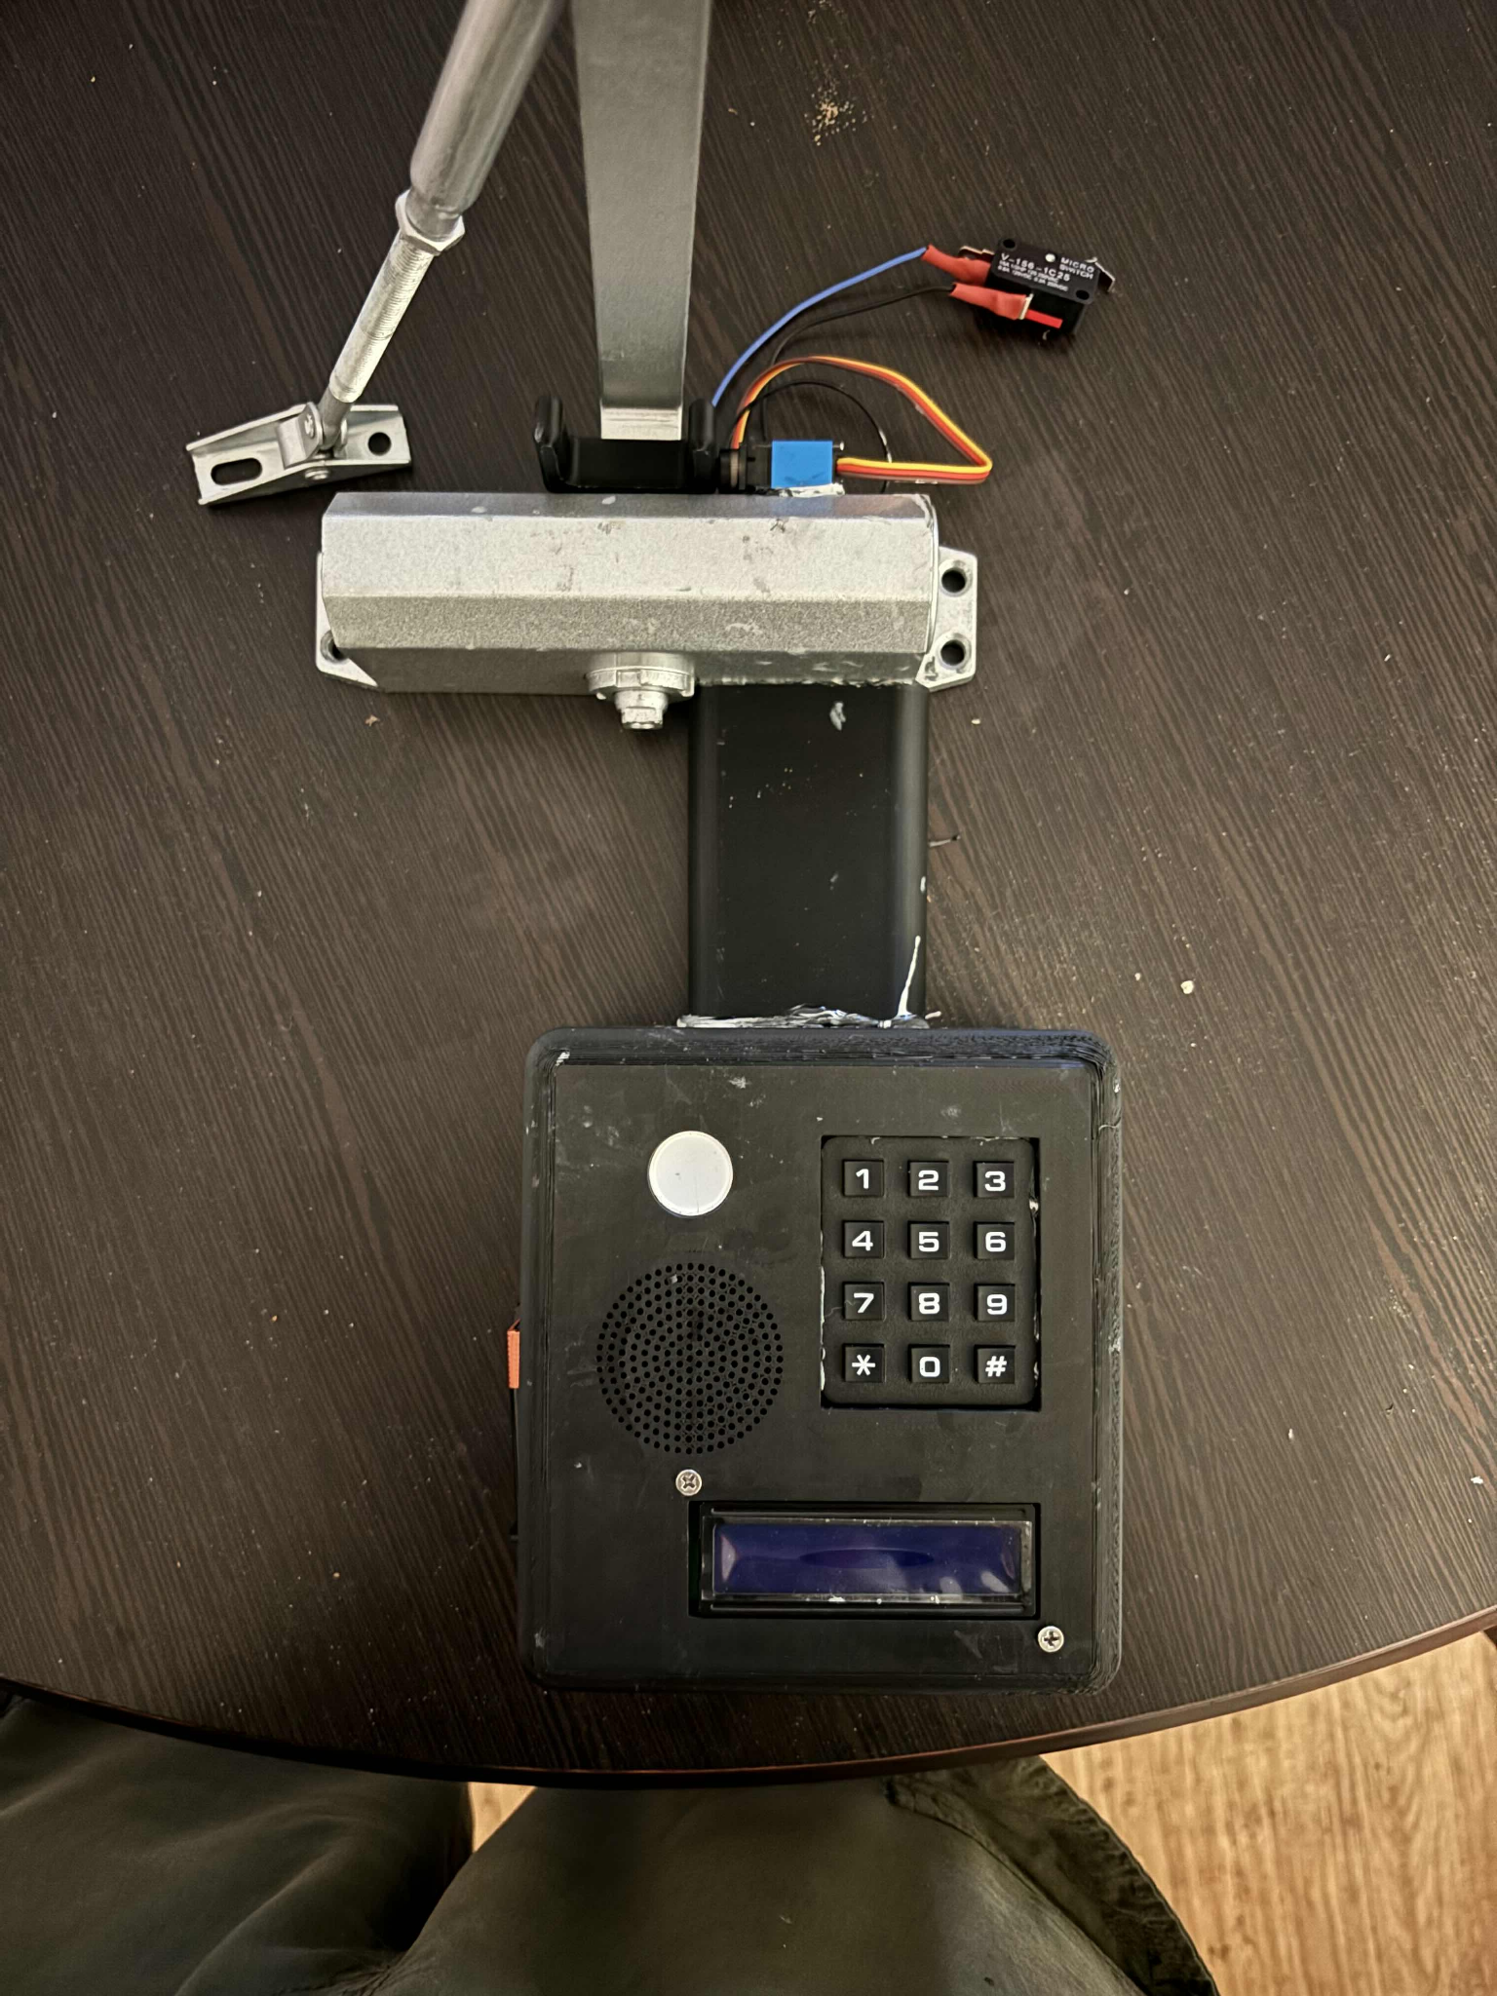

## **Problem**

Controlled laboratory environments (CLE) such as refrigerators, freezers, and incubators are critical for preserving the integrity of biological samples, reagents, and other temperature-sensitive materials. Such biological samples include high-value and irreplaceable items that are essential for ongoing research and diagnostic activities. While state-of-the-art CLEs often include safety measures such as alarms and sensors to prevent the loss of samples due to exposure to ambient conditions, older models often lack these features. This can be seen by looking at the Fisher Isotemp Freezer series. The 13-986-148 model released around 2008 [1] lacks the remote alarms that the 2019 model (FBG25FSSA), has included. [2].

Laboratory materials, which can potentially have lots of value, and possibly years of research, are stored in CLEs worldwide. There have been at least five major laboratory freezer failures since 2012 [3], which have cost laboratories millions of US Dollars. One such failure is when stem cells from cancer-treated children were lost from a hospital freezer at Children’s Hospital Los Angeles in 2019 due to a failure of freezer temperature sensors, which caused major disruptions to future care possibilities and to the patients and their families [4]. This freezer failure led to these irreplaceable stem cells being exposed to higher than intended temperatures and caused a detrimental effect to cell viability. Exposure to ambient conditions should be minimized and has been proven to negatively affect biological material, such as proteins, over time. Even short periods of thawing and refreezing can lead to mild denaturing and loss of proteins. Ten cycles of thawing and refreezing already show at least 5% loss of many types of proteins [5]. As for what this loss might look like financially, the private sector cost per dose for the Pfizer COVID-19 vaccine is $115 [6]. A single shipment of the Pfizer vaccine includes 4875 doses, spread across 5 trays equaling a total cost of $560,625 [7]. A loss of 5% of this shipment will cost the facility approximately $28,000. Ideally, it would be best to prevent this situation from occurring as the loss of materials can lead to significant time and monetary loss.

Lack of safety features means that older CLEs, which have less advanced technology than newer CLEs, present a risk to biological samples that newer models do not. Further, many laboratories often have these older models because they have long functional lifespans and are significantly expensive to upgrade to newer models. Laboratory freezers, for example, are meant to last for about 12 to 15 years [8] and upgrading can cost thousands of dollars [9]. Older CLE devices can fail, and as a result, significant losses in money and samples occurred. For instance, various CLE failures due to mechanical issues or power outages resulted in losses of up to just over $60,000 a month [10]. According to Boston University, for older CLEs, “the risk of potential freezer failure increases in likelihood and severity” [10]. The study is an example that shows how older CLEs are increasingly at risk for viable biological sample storage. Some features, whether it is due to more simplistic technologies that come with older models or due to age, break down and cause trouble for biological samples. However, the devices cannot always compensate for human error without safety features. Modern CLEs are more equipped with systems such as sensors that can help respond to deviations in specifications that impact the biological samples stored in CLEs, while older CLEs do not have safety features that protect the biological samples **[**11]. The more modern CLEs cannot always compensate for human error without safety features since if the newer model has no safety features, the newer CLE is not any better than the older CLE in ensuring safety as there are no additional safety features. This is especially the case as the newer CLE ages over time.

The lack of safety features in older CLEs places an extra burden on users to ensure proper CLE closure, which increases the likelihood of user error. Since mistakes are inevitable, there is a clear and critical need for safety features in these devices. This highlights a market opportunity for an affordable solution to reduce the risks associated with older CLEs and typical user error. We have found a few possible ways for CLEs to fail:

1. Improper setup of environmental parameters
2. Failing or forgetting to close the door properly
3. Spontaneous failure of mechanical or electrical systems

We aim to address cases 1 and 2 with our novel design. The only solution to case 3 is via repair or an upgrade to newer models.

Our novel device’s function is to prevent the loss of biological samples that are stored in a controlled laboratory environment (CLE), such as a -20 C or -40 C freezer, thus preventing the associated monetary loss that results from the loss of materials.

## **Objective**

In pursuit of this aim, here we demonstrate our novel design: the Bio-Refrigerator Security System (BSS). The main function of this device is to minimize the risk to sample integrity due to prolonged exposure to ambient conditions. The device is designed to be power efficient, affordable, easy to install, and easy to use. The BSS is primarily intended to be installed onto older CLEs such as biological laboratory refrigerators, freezers, and incubators that lack modern safety features such as alarms.

## Design Solution

The BSS team’s design solution is an after market modification device that can be installed on a CLE. The BSS design improves on existing CLE locking systems by combining the security measures of alarms and user verification with an automatic closing system. The design has a way to give older CLEs a way to get the locking features to ensure that they can stay closed. The design is a novel design, since we incorporate an automatic closing system to the lock to ensure that the lock can stay closed. When installed, it will alert nearby laboratory workers if the door is left open. Additionally, our design enables mechanical closure of the door. The main housing of the device will be installed on the door of the CLE, and a hydraulic closer will be attached to the top of the CLE body. The main housing of the device will contain a PIN pad that users will use to lock and unlock the CLE. A hook-style lock system is attached atop the closer housing in order to resist opening the CLE while locked. The door status is considered “closed” when a limit switch that is installed on the door is pressed. When not pressed, the door status will read as “open”. The LED and speaker alarms are set to trigger when the door is shown to be open when the door is set to be locked or when the door is open for over two minutes. The device will be powered by disposable 9V batteries (as supplied by the end user). Figure 1 illustrates the device when fully assembled.

For this stage of development, we have decided to proceed with PLA as the main housing material instead of stainless steel based on feedback from previous iterations. Thick PLA is sturdy enough for our use and it is lighter and easier to produce. This also serves as a way to reduce waste since there is no laser cutting and welding involved.

## 

## Assessment of Design Goals

In order to confirm that the Biorefrigerator Security System meets the established product specification, verification tests were conducted to ensure functionality at the individual component, subsystem and full assembly levels.

Table 1: Component Verification Results

| **Component** | **Simplified Test Method** | **Data** | **Data Analysis Method** | **Result Analysis Method** | **Result Analysis** | **Pass/No Pass** |
| --- | --- | --- | --- | --- | --- | --- |
| Battery | Measure battery voltage | 9.68, 9.69, 9.68 | average and standard deviation | Mean ≥ 9 V | Standard Dev. ≤ 0.225 V | Mean: 9.683 V Standard Dev. 0.005 V | PASS |
| Microcontroller | "Hello World" Arduino Protocol | Functional | Binary: functional or nonfunctional | n/a | n/a | PASS |
| Red and Green LED | Input voltage to green and red LED pins | Functional | Binary: functional or nonfunctional | n/a | n/a | PASS |
| Speaker | release alarm sound of 1000 to check for audibility at conversational volume | Functional | Binary: functional or nonfunctional | n/a | n/a | PASS |
| Limit Switch | Attach limit switch to microcontroller. Change in input reading is expected when the lever is pressed | Functional | Binary: functional or nonfunctional | n/a | n/a | PASS |
| LCD Screen | Display the "Hello World" Arduino Protocol | Functional | Binary: functional or nonfunctional | n/a | n/a | PASS |
| Pressurized Door Closer | Pull back the arm of the Door Closer and examine if it returns to the original position when released | Functional | Binary: functional or nonfunctional | n/a | n/a | PASS |

Table 2: Subsystem Verification Results

| **Subsystem** | **Simplified Test Method** | **Result Analysis Method** | **Result Analysis** | **Pass/No Pass** |
| --- | --- | --- | --- | --- |
| Alarm System 1 | Press down the lever on the limit switch then release for 2 seconds. Both alarms should trigger. | Binary: functional or nonfunctional | n/a | PASS |
| Alarm System 2 | Input the PIN Code "77777777". Both alarms should trigger | Binary: functional or nonfunctional | n/a | PASS |
| PIN Pad and Lock 1 | Input the PIN Code "1234567". Servo arm should rotate 90 degrees clockwise in the locked state and 90 degrees counterclockwise in the open state | Binary: functional or nonfunctional | n/a | PASS |

Table 3: Validation Results

| **Metric** | **Simplified Test Method** | **Scale (If Needed)** | **Result Analysis Method** | **Result Analysis** | **Pass/No Pass** |
| --- | --- | --- | --- | --- | --- |
| Final Cost | Sum of used parts in USD | n/a | Sum < 200 is considered a "pass" | $180 < $200 | PASS |
| Final Weight | Weigh final assembly with a scale in pounds | n/a | Final Weight =< 7 pounds is considered a "pass" | 3.6 < 7 lbs | PASS |
| Battery Life | Measure average current usage and calculate approximate battery life using 550 mAh/current draw | n/a | Battery life >= 6 months | Current draw = 12 mA  Battery Life = 36 hours | No Pass |
| Ease of Use | Qualitative: Users given a survey to rate understanding of device usage | fully intuitive --> some guidance needed --> training required | Some guidance needed is considered a "pass" |  | TBD |
| Ease of Handling | Qualitative: Users will be given a survey to rate if the device makes the CLE more difficult to operate or not | no difference--> slightly more difficult--> moderately more difficult--> much more difficult | Slightly more difficult to operate is considered a " pass" |  | TBD |
| Security | Measure force required to make the hook lock detach from the servo | n/a | Force >= 10 lbs | Force = 12 lbs | PASS |
| User Log | n/a | n/a | Binary: functional or nonfunctional | n/a | PASS |

All verification tests were passed at the component and subsystem levels. This means that all components and the base BSS code function as intended.

The validation tests that were performed include all except for the Ease of Use and Ease of Handling tests. These tests have to be completed by users after receiving a functional version of the device. Two user needs metrics were not met with the current version of the BSS, those being for a long lasting battery life and a user log.

## Value Impact

The Biorefrigerator Security System design improves on existing CLE locking systems by combining the security measures of alarms and user verification with an automatic closing system. These security measures ensure that if someone forgets to close the door or doesn’t close it properly, then the CLE will close by itself. Additionally, if the door gets propped open then the alarm will sound to alert nearby users to close the CLE. The device design uses preventative as well as corrective measures to minimize the monetary costs from loss of biological materials stored in CLEs. As mentioned in the “problem” section above, losing even a small percentage of laboratory materials can lead to thousands of dollars of loss.

There is not a widespread solution for a CLE locking system that is reasonably priced and easily accessible, as shown in Table 4 below. Table 4 compares our design to some alternatives on the market as well as combinations of devices to reach similar functionality. The customer can benefit from having a secure system to protect their samples at a much lower price when compared to devices that have similar features. Purchasing a newer CLE model will accomplish the same task, however this will be much more expensive than purchasing a BSS device. The combination of an alarm, PIN pad, lock system and hydraulic closure means that the BSS will retrofit older CLEs with technology akin to modern CLE safety features, aftermarket locks, and door-closing solutions to provide an all in one device for end users. The combined systems will meet a novel idea for the design, which is to make an automatic closing system to keep the CLE locked.

Some of the competitors to the Biorefrigerator Security System are listed below. The BEOL Biological Refrigerator Smart Lock has features such as remote lock authorization and electronic notifications that our design does not, however this comes at a much higher cost per unit of nearly $1000 per lock. The Monnit Remote Temperature Monitoring system allows users to view a graph of CLE temperature over time and also includes electronic notifications that can be configured by the user. This system requires not only a higher initial cost of $369, but also a $45 per year subscription to unlock automated reporting and multiple user authorization. The final competitor would be a combination of devices that combine to reach similar functionality to the Biorefrigerator Security System. This combination comes out to a cheaper price of $54.22 but lacks any way to authorize or verify users which can lead to a lack of accountability.

Table 4: Benchmarking of the Biorefrigerator Security System

| **Alternative Number** | **Device** | **Door Security** | **Status Sensor** | **Automatic Door Closing** | **Alarm** | **User Log** | **Price / One CLE** | **Vendor** |
| --- | --- | --- | --- | --- | --- | --- | --- | --- |
| 0 | Biorefrigerator Security System | **X** | **X** | **X** | **X** | **X** | $172 | n/a |
| 1 | BEOL Biological Refrigerator Smart Lock | **X** | **X** |  | **X** | **X** | $984 | BEOL |
| 2 | [Monnit Remote Temperature Monitoring System](https://www.monnit.com/temperature-monitoring/select-products/) |  | **X** |  | **X** |  | $369 + $45/yr | Monnit |
| 3 | [YEYA Refrigerator Lock](https://www.amazon.com/Refrigerator-Cabinet-Adhesive-Yeya-Standard/dp/B096QSGRG3/ref=sr_1_1?crid=1QBRBI64C3KJM&keywords=fridge+lock+combination&qid=1697565725&sprefix=fridge+lock+combination%2Caps%2C158&sr=8-1) | **X** |  |  |  |  | $6.25 | Amazon |
| 3 | [Freezer Door Alarm](https://www.amazon.com/Freezer-Window-Reminder-Office-School/dp/B0BX9FZ6CB/ref=sr_1_6?crid=M93LOUH7QYZR&dib=eyJ2IjoiMSJ9.alN86vbUQqt6m7kTLhMMxIvmq2IYH562DVMWjLor9SEEm4Ub8WaHZM5KUthAhQhbwQSjZMYpjDAsACTx7jf1IdIcCRb_omqTcttDZYStzDg7EDcI-sO4FyhfPoFtxVf9XxqsJ-h1JHxoDO0S6wn-eWrcW0LllVz-w4BcZRxMfXlP5NAh1Ox4E8NW89I430ujfB1C20AE9815P_OpzlKTVrf3YlYsRyjAp62B5QRLZXhPxij58kHf4GXaaBMZAnjXllsuLxSxp4tK07vRBhwkG-qGDoO9wlIJymcHKY7XMjQ.rGjz54jLmFpj370umoFvUX7vzyathf8Plclf3tJFbI8&dib_tag=se&keywords=Open%2Bclose%2Bsensor&qid=1715273470&sprefix=open%2Bclose%2Bsensor%2Caps%2C160&sr=8-6&th=1) |  | **X** |  | **X** |  | $16.99 | Amazon |
| 3 | [BRINKS Commercial - Light Duty Residential Door Closer](https://www.amazon.com/BRINKS-Commercial-Residential-180-Degree-Adjustable/dp/B09C18PHBN/ref=sr_1_15_sspa?crid=2MBJMPPYGD7RM&dib=eyJ2IjoiMSJ9.0ezEOHe8QyIM-ea4AqCBhpgWbxGgDqMiN4k1uuVyqsyfMqRmC326rEIwVSwUlElDk8yB3cU2F-RVFyZxDoL3V4OTFSTMHg14a9AL_xy1WCIhDb1-yhFH4mSJPSZVuov_LwRfcjELHC5_yxl_xPMI6eNpfRu7Wqw9WBX5splkUuXANO4jEmHeRf-GelKm2ySZhWkBU8NTaVEvY-yfMGa-MMFuoMo2CZvcXxa_13wEzyysK53_sidqlRKGAlClo0kxdZpF6K6nz9qzt2CkxNYul860r-_qoeP1I4_ZJPtTDhU.yxAaWdu6bziTjkFYULao25qZJQ5Oqq-0aepeg7VYNKU&dib_tag=se&keywords=automatic%2Bdoor%2Bcloser&qid=1715273632&s=hi&sprefix=automatioc%2Bdoor%2Bclos%2Ctools%2C196&sr=1-15-spons&sp_csd=d2lkZ2V0TmFtZT1zcF9tdGY&th=1) |  |  | **X** |  |  | $30.98 | Amazon |
| 3 | Total | **X** | **X** | **X** | **X** |  | $54.22 |  |

## Future Work and Improvements

To advance the project further and improve on the current design, we have ideas on how we can do so. There exist three main categories that we could improve in future revisions. These include modifications to the casing, addition of remote capabilities, and inclusion of additional sensors.

The casing itself can be changed to include further support for the circuitry components by adding standoffs and internal brackets. In addition, the case should be further expanded to allow for easier installation and mounting of circuitry components. A custom circuit board would be another improvement as this would reduce wiring inside the case as components could be directly soldered onto a singular board. This would also drastically reduce the power draw of the system and thus also significantly improve battery life. We can also attempt to find a way to modify the sizing of the lock so that it can connect and fit onto more models of CLEs.

Another possible improvement is to change the way the device stores user information so that using the device automatically creates an audit log onto a spreadsheet. In order to automatically log information onto a spreadsheet, we can incorporate remote connectivity with WiFi and/or Bluetooth onto the code. In this way, it would also be much easier for user verification to occur as additional PINs may be assigned remotely for authorized users. Additionally, we can utilize these technologies to remotely unlock and lock the CLE.

The addition of additional sensors, such as temperature sensors, would allow for older CLEs to gain more of the safety features that new CLEs have. The addition of temperature sensors would help to ensure that CLE temperature settings are accurate, which may deviate as the device ages due to wear.

# 

# **Client Report**

The importance of performing verification and validation tests is to close the loop on the waterfall design process. The FDA waterfall design process for developing a medical device is a sequential approach that starts with identifying user needs and ends with a finished medical device. The process begins with research to identify user needs, which inform initial design concepts. These concepts are screened based on feasibility, cost, and effectiveness, which leads to the selection and development of a prototype. The prototype undergoes verification to ensure it meets design specifications and validation to confirm it fulfills user needs. Although our device is not a medical device, the waterfall design process provided a good support and direction for our device.

Figure 2: Waterfall Design Process

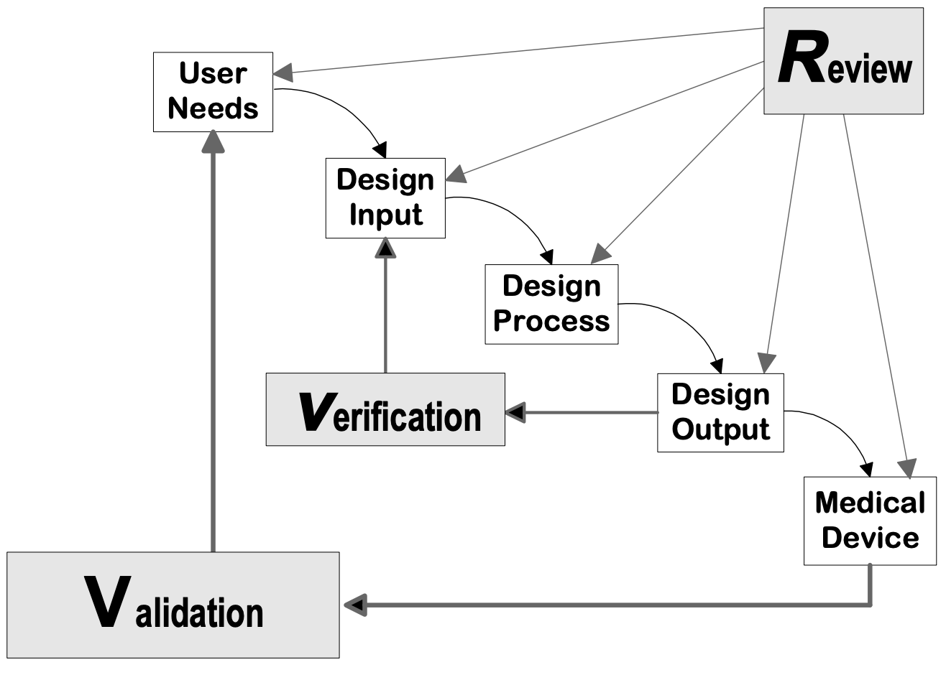

In this section, the processes for how the device was manufactured and assembled, as well as how it should be used are below. Additionally, all verification and validation testing protocols are listed. This is to ensure that the results of testing can be repeated to maintain consistency in future manufacturing.Additionally, all verification and validation testing protocols are listed. This is to ensure that the results of testing can be repeated to maintain consistency in future manufacturing. We specify safety precautions to ensure the user knows how to safely use the device. The bill of materials and engineering drawings of the final design are included below.

## Instructions for Manufacturing

The case of the device and the mounting block need to be manufactured while the closer just needs to be modified. Otherwise, all other parts are pre-made and can be inserted afterwards.

1. Using the drawings included in the appendix, 3D-print the front panel, back panel, and wire channel using PLA filament. After printing, remove the extraneous plastic.
2. Measure out the areas where the microprocessor, LCD, and PIN pad have holes after they are inserted, then drill holes for them.

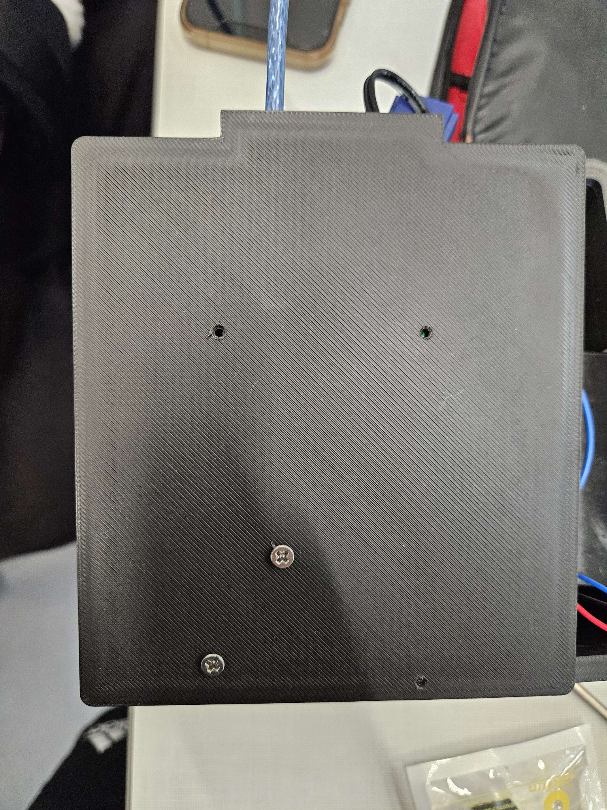

Figure 3: Backplate Holes

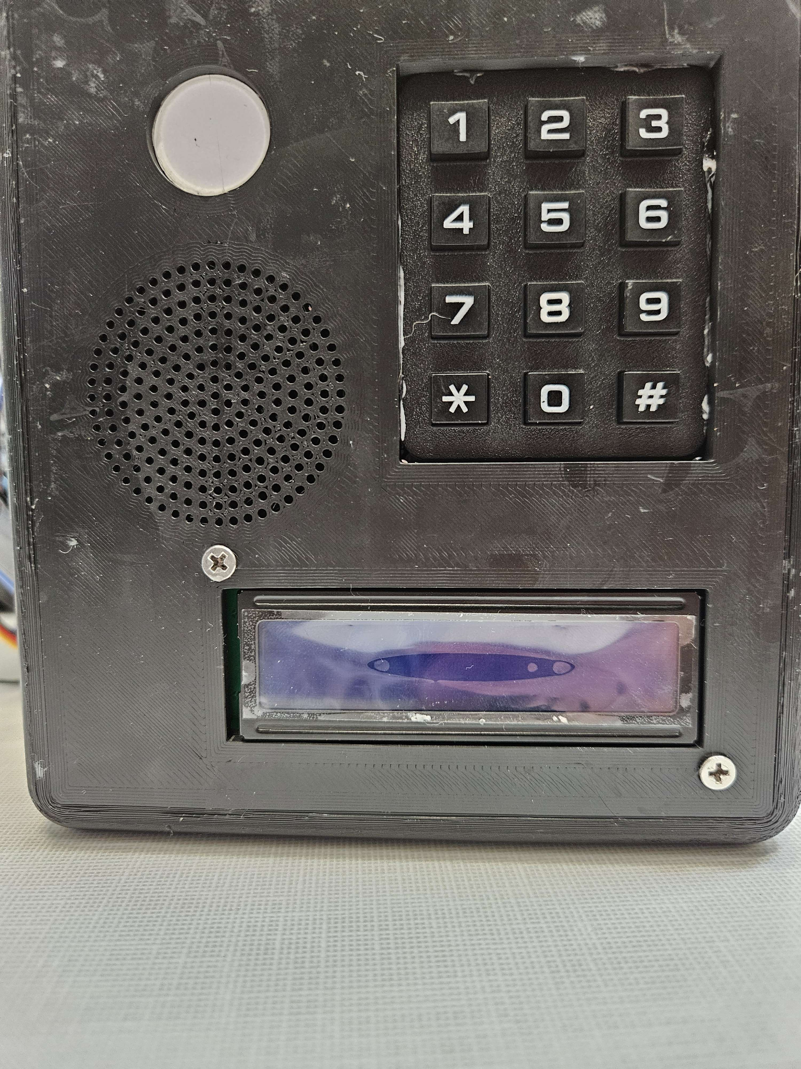

Figure 4: Front Plate holes

1. Mill a 2” x ½” slot in the back of the closer either left or right of center, removed from the pivot point of the closer by at least ½”. This ensures that the wire channel does not interfere with the motion of the door closer.

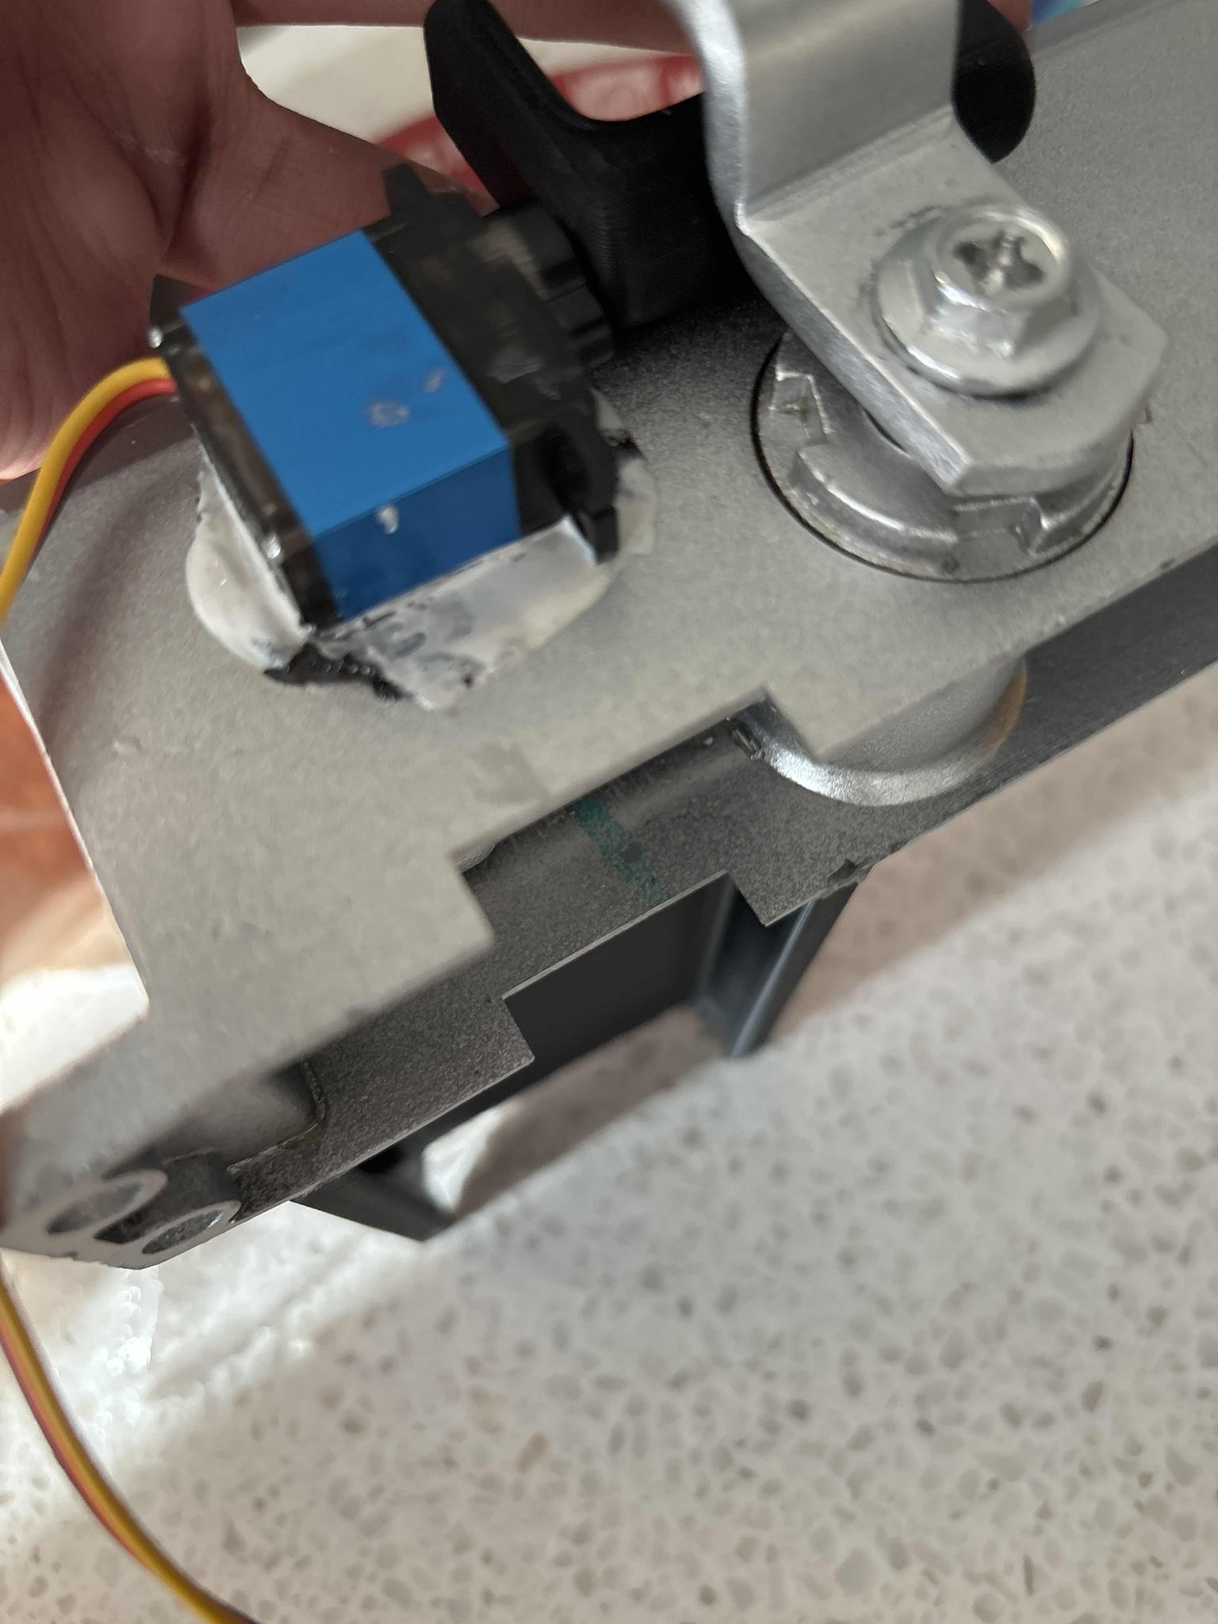

Figure 5: Milled Cable Channel

1. After the parts are prepared, sand both short sides of the wire channel, the bottom of the door closer, and the top of the front panel.
2. Use epoxy to assemble these 3 components as shown in the assembly drawing.
3. Use metal sheet cutters to cut off the rotating section of the limit switch arm
4. Use pliers to bend the limit switch arm into the shape shown below

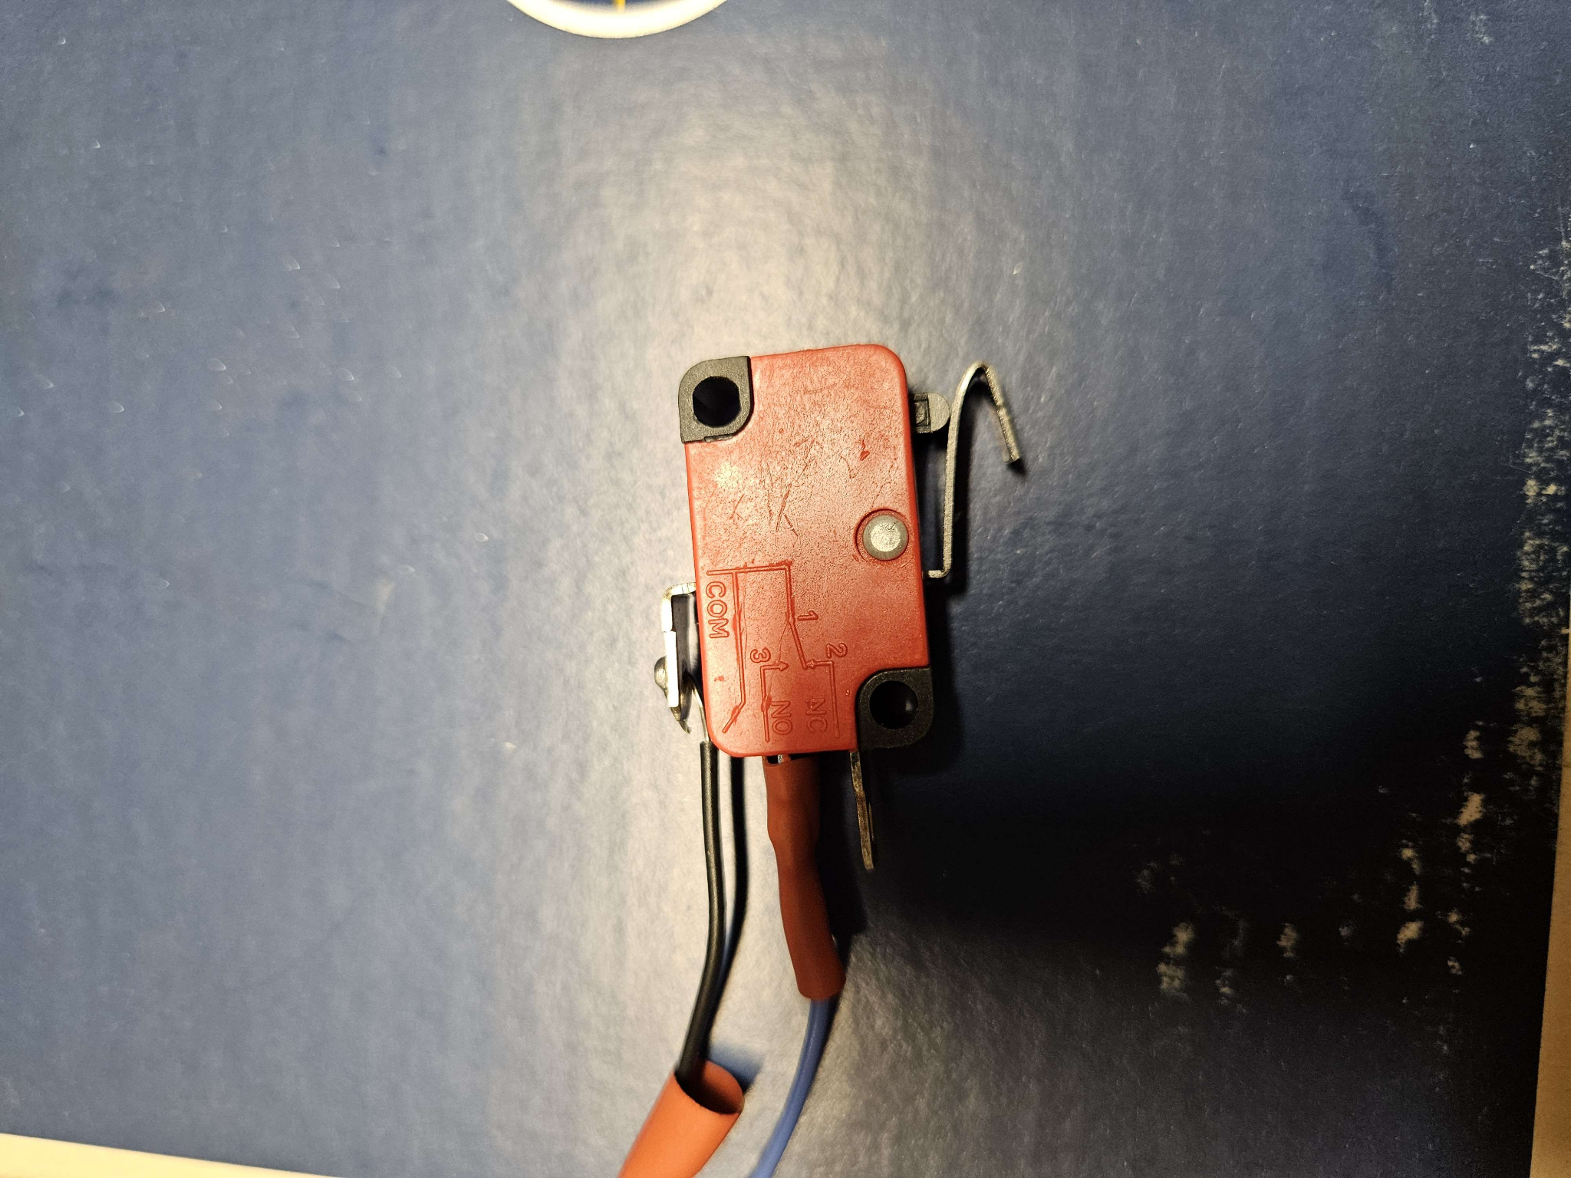

Figure 6: Modified Limit Switch

1. Cut two red wires and two black wires to 6” lengths and use wire strippers to remove ⅜” of the rubber from both ends of each wire
2. Solder one end of one red wire to the positive terminal of the speaker
3. Solder one end of one red wire to the NO terminal of the limit switch and wrap in electrical tape or heat shrink
4. Solder one end of one black wire to the ground terminal of the speaker
5. Solder one end of one black wire to the COM terminal of the limit switch and wrap in electrical tape or heat shrink

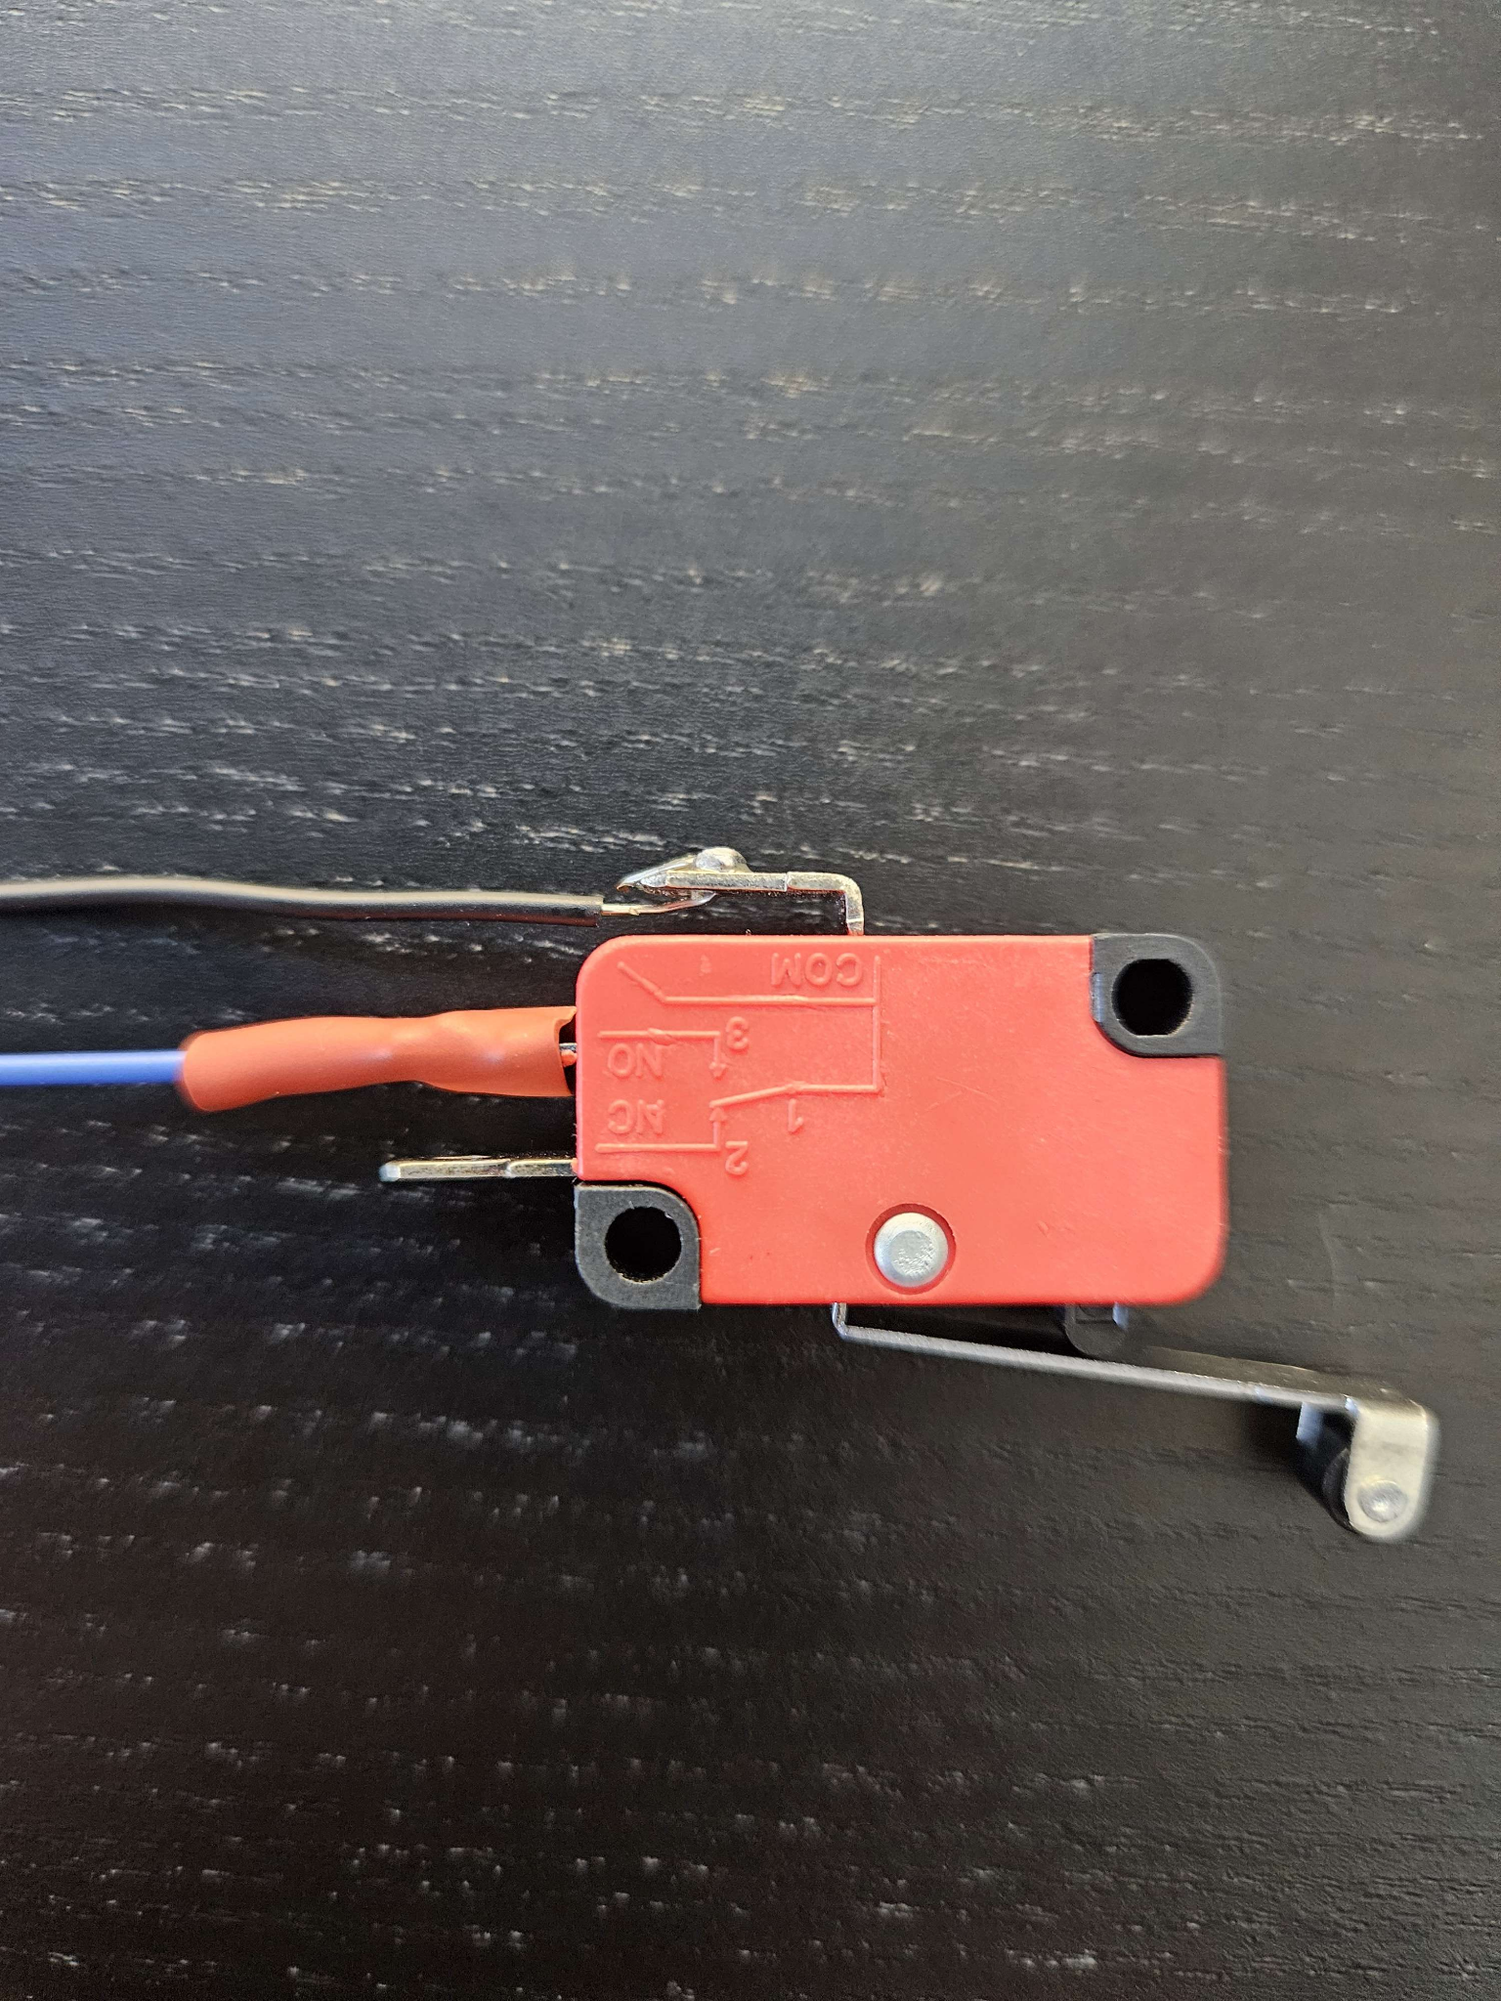

Figure 7: Soldered limit switch

1. Finally, for the mounting block, first cut a 2.5” x 1” and 2.5” x 3” piece of 18-gauge steel.
2. Then, drill holes in the 2.5” x 1” piece that are centered 0.5” width-wise, are 1.6”apart, and use a #2 drill for diameter (0.221”).
3. Finally, epoxy the two pieces together as shown in the mounting block drawing.

## 

## Instructions for Assembly

1. Take all circuit components and place them into their respective slots, making sure that the components are in the right orientation as seen in the photo below

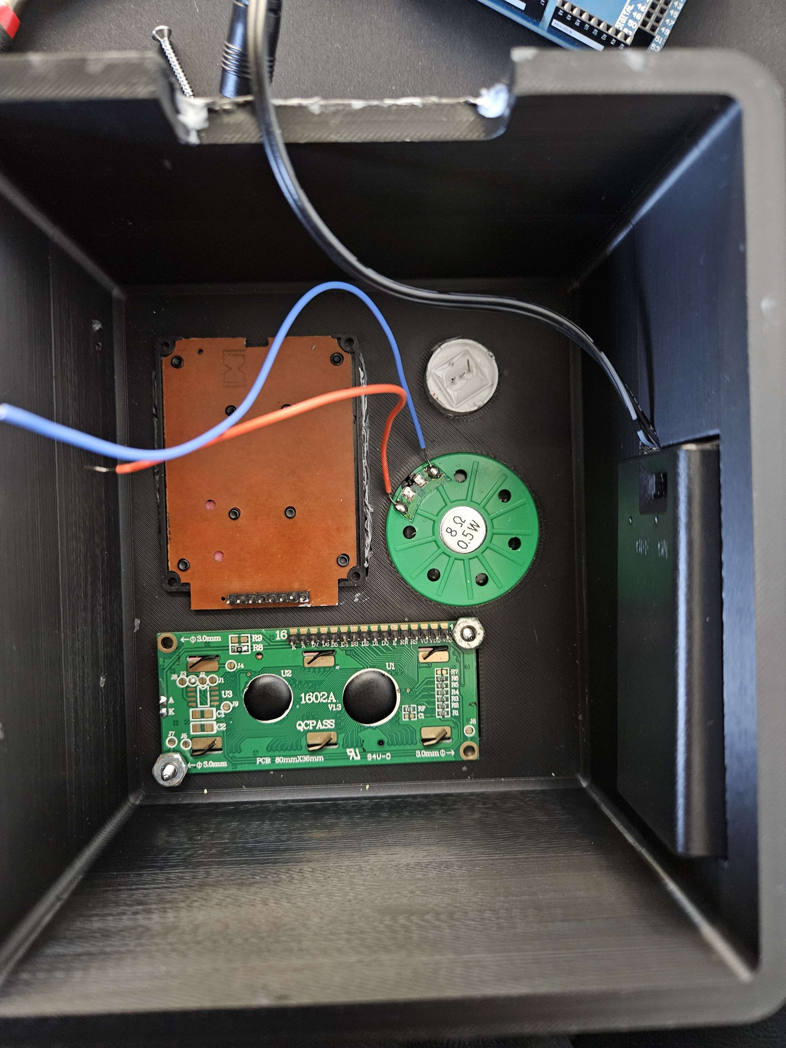

Figure 8: Components in Place

1. Screw in components with respective screws and secure with the included nuts

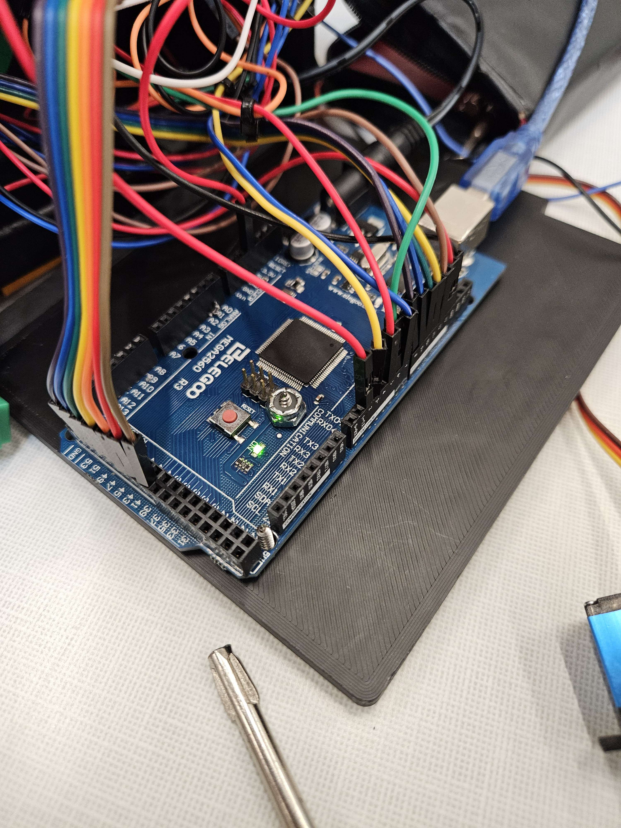

Figure 9: Arduino Secured onto the Backplate

1. Attach wires to all components and thread the limit switch and servo wires through the wire channel
2. Use one of the mini breadboards to wire the included potentiometer for the LCD screen
3. Wire to the microcontroller as based on the wiring diagram in figure 14, using two of the mini breadboards as power rails
4. Remove the included servo arm from the servo motor
5. Pressure-fit the Hook Arm part onto the servo motor
6. Use epoxy to secure the servo onto the pressurized closer as shown in the photo below
7. Press the backplate into the back opening of the front plate

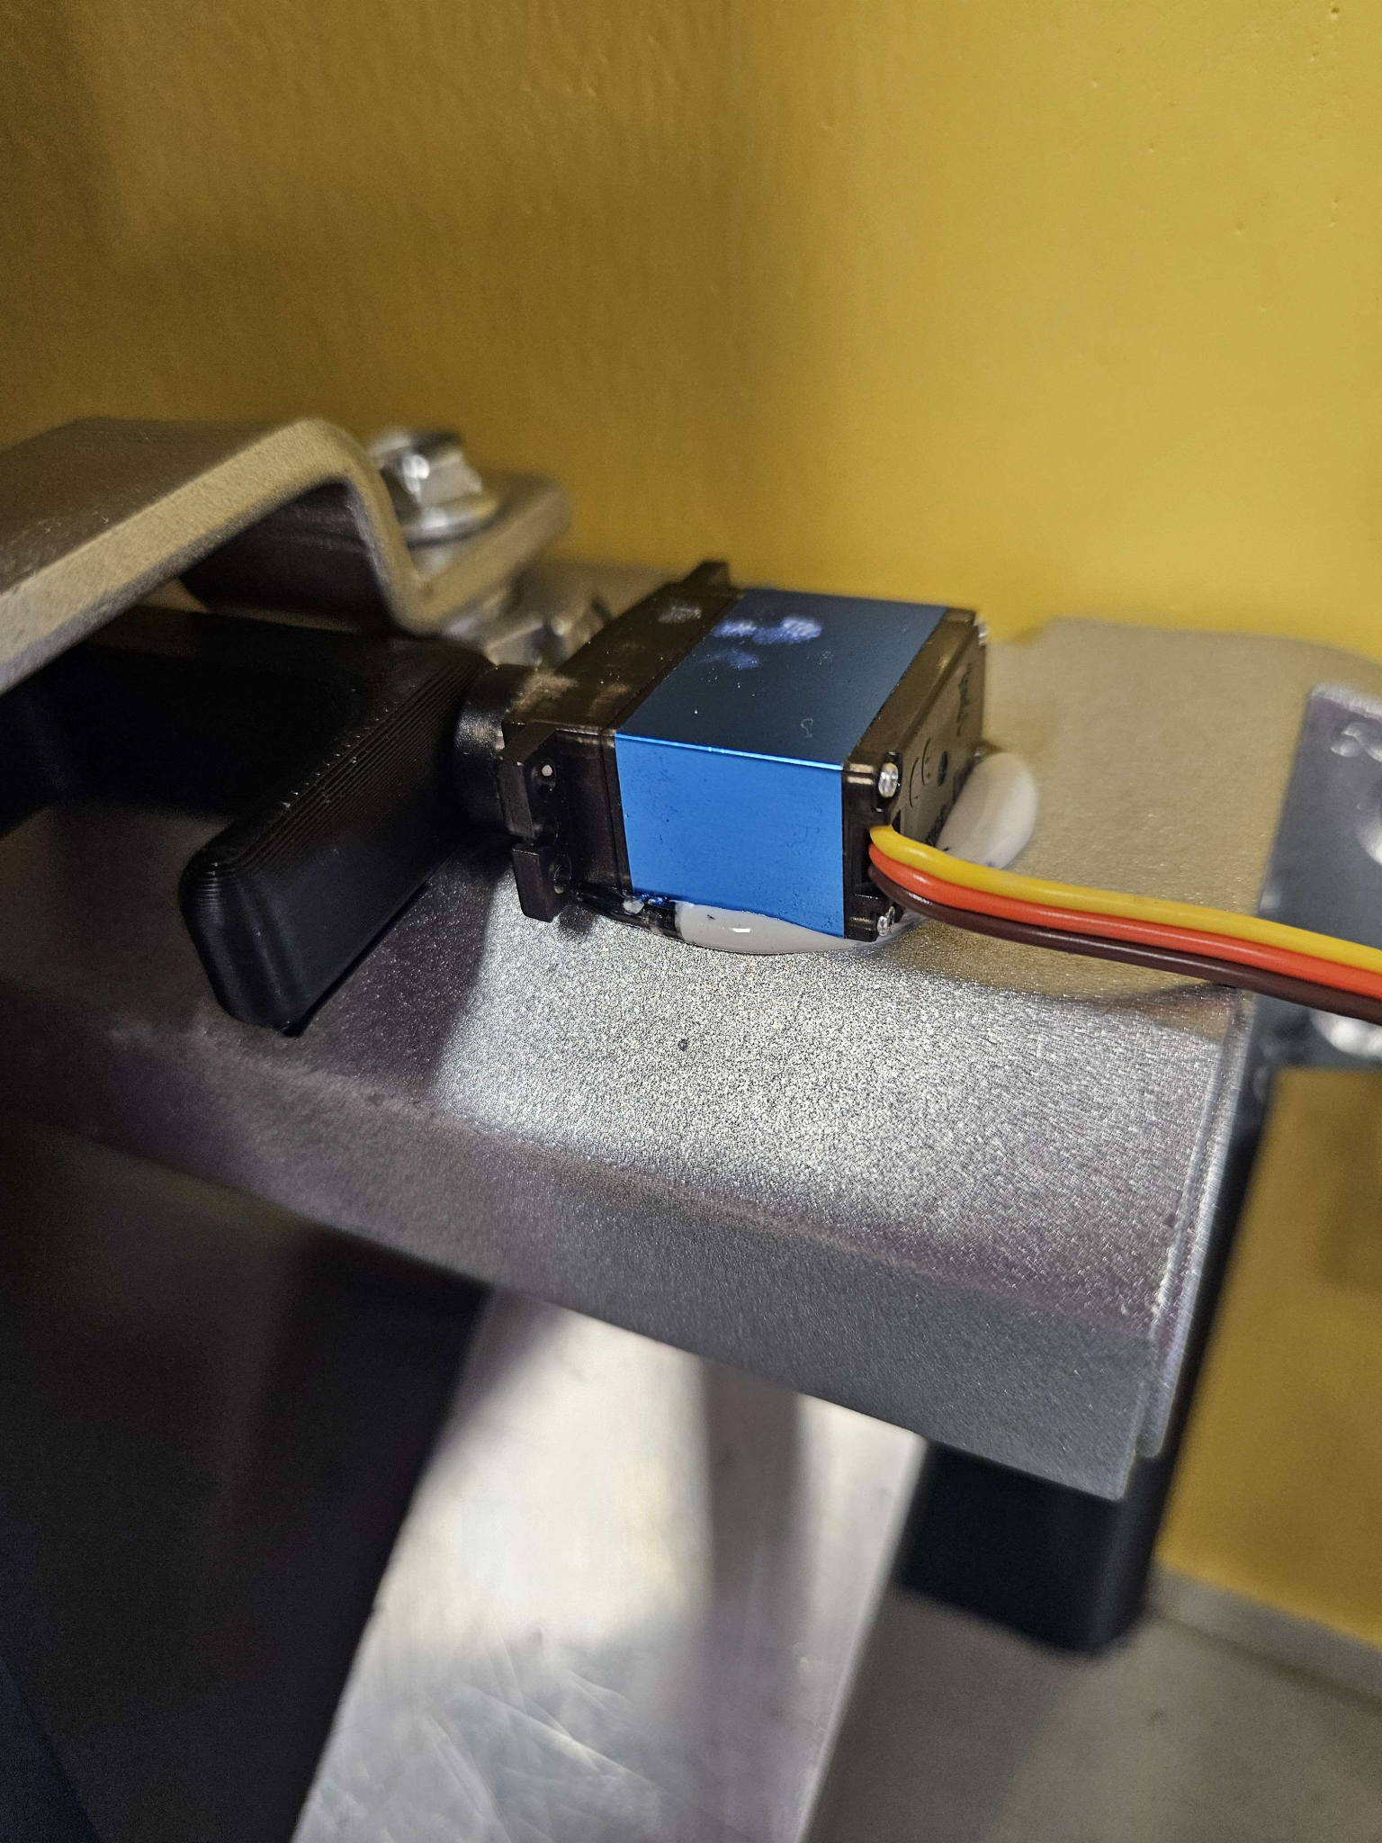

Figure 10: Servo attached to the Pressurized Closer

## Instruction for Use

### **Installation**

1. Attach the limit switch to the door of the CLE using epoxy as seen below. Note that when properly installed, the metal arm of the limit switch made a small click noise while closing.

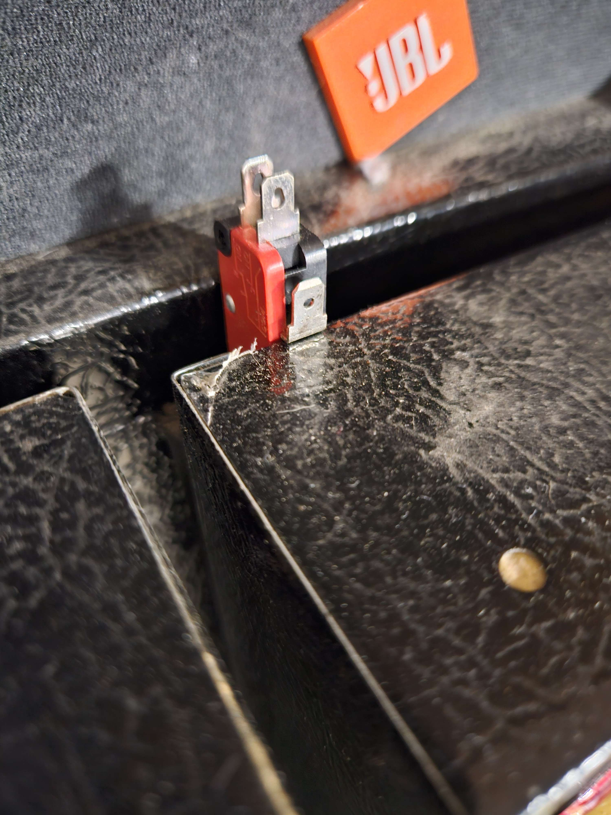

Figure 11: Installation of the Limit Switch

1. Allow the epoxy to cure for 24 hours. Do not move the door of the CLE for at least 30 minutes. After that, you may slowly open and close the door, however for best results do not use the CLE until 24 hours have passed.
2. While the epoxy for the limit switch cures, epoxy the body and closer arm onto the CLE such that the closer arm’s top point is above the fridge.
3. Close the CLE
   1. Ensure that the LED is green when the CLE is closed
4. Attach the mounting block onto the top of the CLE using epoxy such that the hydraulic closer arm can be screwed onto it
5. Epoxy the backplate onto the CLE door so that the closer arm rests parallel to the ground

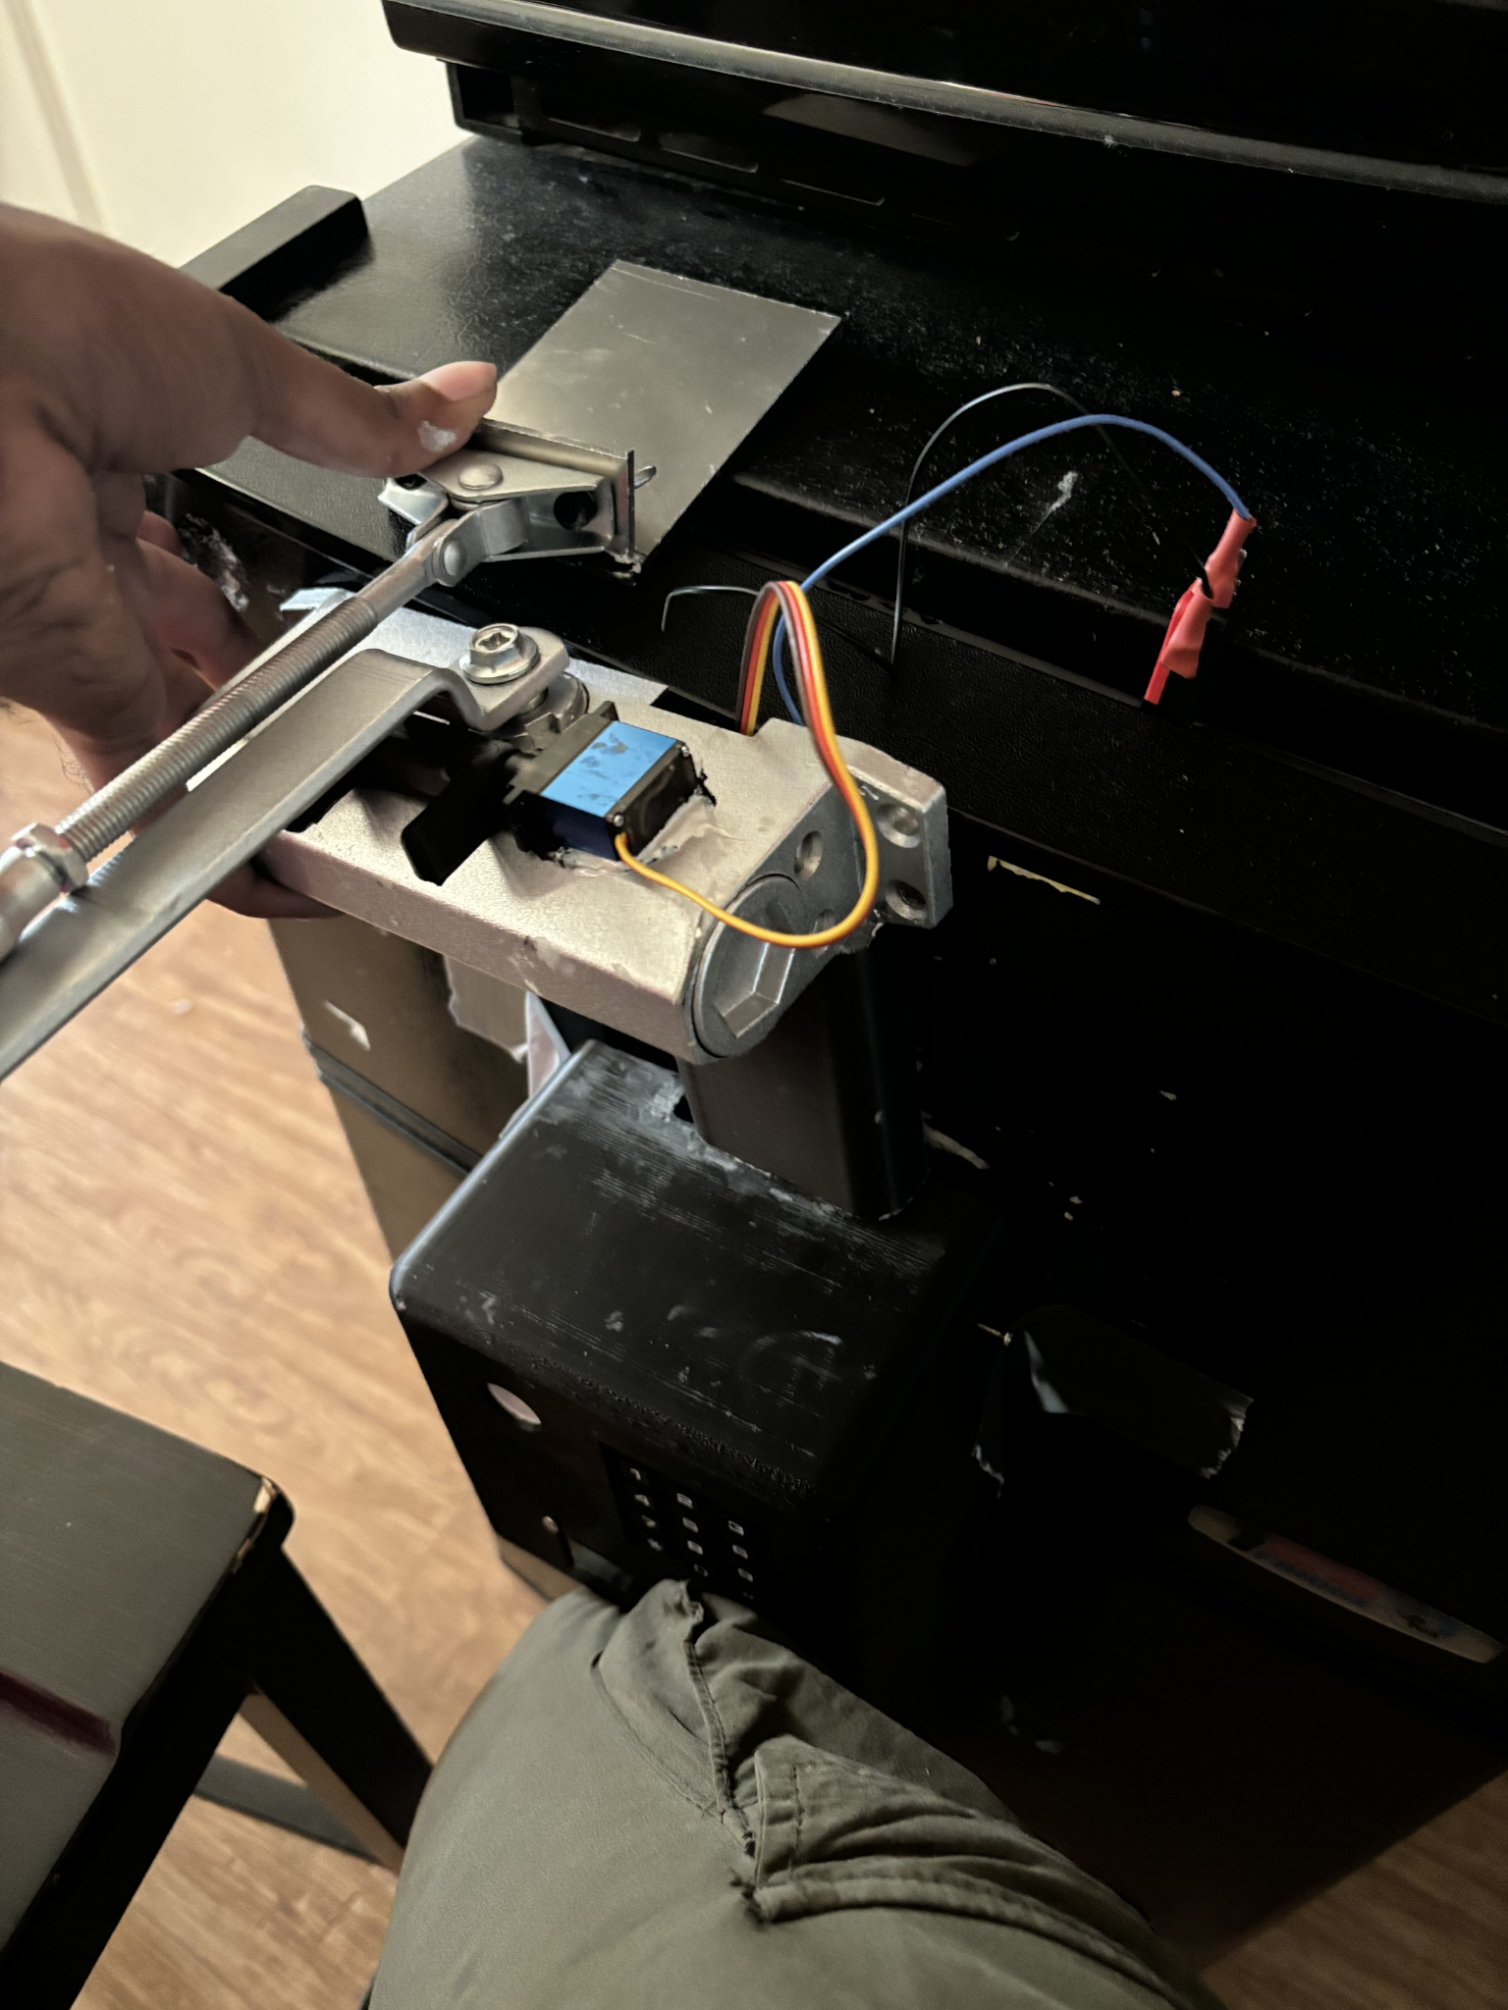

Figure 12: Mounting Block Installation

1. After the epoxy has cured, screw the hydraulic closer arm onto the mounting block
2. Switch the power slider on the battery holder to the “on” position
   1. Ensure that the LCD screen displays “Monitoring”
      1. If the LCD screen is too dim, turn the LCD potentiometer wiper clockwise

### **Use of the PIN Pad**

1. Preset PIN passcodes have already been installed onto the device, input the preset PIN passcodes in order to lock or unlock the device from opening and closing.
2. There are currently 3 user passcodes in the device, use and share each passcode to specified people to keep track who has opened the device
   1. Note: each passcode is a 7 digit passcode
   2. You can see your inputs on the LCD screen
3. If you do not like the preset PIN passcode, press “*” on the PIN Pad, this will allow you to change your respective passcode after the proper passcode has been applied. After the initial passcode has been applied, please add your new wanted passcode into the system.
4. If you need to check the previous person who used to lock the device, press “#”, this will display the previous user. "M", "U", or "V" should display for each user, short for Master, User 1, and User 2.

### **Changing the Battery**

1. Locate the battery holder on the left side of the device
2. Slide the cover off, towards the top of the holder which houses the wire
3. Push downward on the battery, away from the holder terminals
4. Replace with another 9V battery by reversing step 3 until a firm connection is felt
5. Slide the battery holder cover back on.

## Safety Precautions

There are several safety precautions that should be heeded when handling the device so as to minimize risk of injury and device damage.

1. The device should be stable on the CLE and not be at risk of falling, as that can result in risks of exposed wires and other parts that may injure a person.

i. This means that any screws and fasteners should be tightened completely

1. The device, especially the interiors where there are wires, should not be exposed to any liquid substances as wiring touching water can result in detrimental effects to a user and the device.
2. The alarm flash could potentially, at worst, cause seizures to someone who is epileptic, even though the odds are low for that to happen.

i. As long as entering the pincode results in the ceasing of alarm flashing and sound, then this should not be a problem as it is preventable.

1. Do not try to open the box for no reason besides fixing the interior, as there is a risk of the parts coming off of their intended positions.
2. Ensure the area is exposed to excessive heat or the parts may not function properly due to temperature effects.

## 

## Recognized Consensus Standards

Based on a thorough search of the FDA Recognized Consensus Standards website, only one applicable Recognized Consensus Standard was found. This is UL 1642 for lithium batteries, which is meant to “reduce the risk of injury due to fire or explosion” [12].

Given the emphasis on electrical safety and reliability in devices used in laboratory settings, following the relevant standards is of utmost importance. In this context, a device that consists of an alarm and locking device should meet standards for electrical safety, functionality, and reliability. To ensure that these standards are met, the following section goes over verification processes to ensure that all components and systems function properly along with validation testing to ensure the system works as intended when meeting user needs. Here are the following standards we will be using:

Table 5: Standards Table

| **Standard** | **Description of Standard** |
| --- | --- |
| ANSI C18.1M-2021 | This standard refers to portable primary cells and batteries for the purpose of ensuring electrical and physical interchangeability, minimizing proliferation, and defining a standard of performance. |
| ANSI/BHMA A156.4-2019 | This standard pertains to door closers, outlining specifications and requirements for their design, testing, and performance. It ensures the reliability and safety of door closer mechanisms in various applications. Evaluations conducted under this standard include those of door control, durability, appearance, and pivots. |
| IEC 60601-1-8 Ed. 2.2 b:2020 | This standard relates to medical electrical equipment, specifically focusing on the alarms and alarm systems used in medical devices. It provides guidelines for the design, testing, and implementation of alarm systems to ensure their effectiveness and reliability in alerting healthcare professionals to potential issues. |
| Occupational Safety and Health Standard 1910.95 | Occupational Noise Exposure: This standard pertains to the maximum noise level that workers can be exposed to for varying lengths of working hours. |
| IEC 63356-2 Ed. 1.0 b:2022 | This standard focuses on LED light sources. It outlines requirements and testing procedures to ensure these components' reliability, safety, and performance in electrical systems. |

## 

## Verification and Validation Protocol

Verification testing is done to ensure functionality at all levels of assembly. Testing was done at the component and subsystem level. Testing at the component levels is crucial to detect issues with the individual parts since it is easier to fix issues when it is just an individual component failing, instead of a subsystem or full assembly with multiple methods of failure beyond component failure.. Once the component tests are completed, the subsystems: the PIN pad and lock, along with the alarm subsystems, are tested to ensure that the combined regions for the functions of either the locking mechanism or the alarm work before combining them for a full assembly. Full assembly testing has not been completed, meaning that subsequent tests for client usability cannot be conducted at this time. Validation tests involve assessments to confirm that the device meets user needs. The user needs of Ease of Use and Ease of handling are assessed with a qualitative survey that will be provided when users receive functional versions of the BSS. Each of these qualitative user needs will be graded on the scale specified in Table 2. Qualitative validation tests are performed to check that the user needs of the design are met, such as ease of use and handling. These tests are not yet completed as users have not been given a functional version to test on their CLEs.

Table 6: Validation Testing Protocols

| **Test** | **Units** | **Test Protocol** | **Target** |
| --- | --- | --- | --- |
| Cost | US Dollars | 1. Sum final costs of components and materials | $200 or less |
| Weight | Pounds | 1. Weigh the final assembly with a digital scale. | 10 lbs or less |
| Battery Life | Months | 1. Use a multimeter to measure the current usage of the device during operation. 2. Repeat 3 times. 3. Use the average current to calculate the theoretical battery life. | 6 months or more |
| Ease of Use | Qualitative | Users will be given a survey to rate the device on intuitive device operation was using the following scale:  fully intuitive --> some guidance needed --> training required | Some Guidance Needed |
| Ease of Handling | Qualitative | Users will be given a survey to rate the device on how much more difficult the BSS made operating the CLE using the following scale:  no difference--> slightly more difficult--> moderately more difficult--> much more difficult | Slightly More Difficult |
| Security | Pounds | 1. Remove the included servo arm from the servo motor 2. Pressure fit the Hook Lock part onto the servo motor 3. Using a scale, measure the amount of force required to pull the Hook Lock off of the servo motor. | Force >= 10 Pounds |
| User Log | Binary | Binary: Functional or nonfunctional | Functional |

The intended gross cost for the whole assembly is under $200 per unit, since our initial surveys indicated that people would pay $150 to $300 for a CLE lock. For battery life, the ideal user experience would be one in which the user does not have to be concerned about the battery running out often. Since typical uses of 9-volt batteries have 6-month lifetimes, we will also be aiming for a minimum 6-month lifetime between battery changes as according to our verification plans above.Also, the final weight of the assembled device should be light enough to comfortably carry and mount on a CLE, so under 10 pounds would be ideal. This number is arbitrary, since the National Institute for Occupational Safety and Health (NIOSH) sets an upper limit for lifting a load with 2 hands as 51 lbs [13]. While this isn’t a regulation by OSHA, but instead just a guideline, our device is already far lighter than this guideline. Therefore, our self-imposed 10 pound limit is the maximum weight we have set for both lifting and mounting a device comfortably for an able-bodied person.

In the future, after more devices are created and sold, our plan is to encourage customers to fill out a survey on their satisfaction with the product, which will gather information on metrics such as how easy our device was to set up and operate. Along with the survey, we will be testing random units in line with the validation, verification, and failure modes tables laid out in this report. If we find that any of our metrics are measured to be outside of our desired range, we will implement plans to improve the design and issue recalls if an outstanding issue is discovered. For example, if we find that the speaker we decided to use has a chance of being too loud for OSHA requirements, we will issue recalls and replace the speaker with a different one. However, some issues do not warrant a recall, depending on the severity and frequency. An example of an issue that does not warrant a recall would be if our suppliers for materials increased prices, causing the cost of manufacturing to be too high. In a situation like this, we would find new suppliers and organize our manufacturing to account for it.

The next section will show how the verification tests for the device were done, as well as the results. The goal of verification tests is to confirm all used materials are functional prior to assembly. This is to ensure that no other factors can affect future tests. This phase includes an assessment of the battery, microcontroller, and closer. Afterward, we will test components as a subsystem and finally test the entire system overall. This will help us focus on ensuring that our devices meet the requirements given on our EDS.

Figure 13: Verification Flow Chart

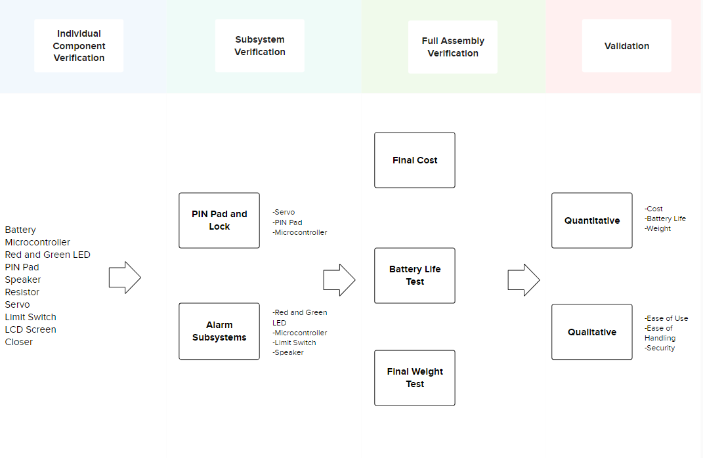

### Component Verification Tests

This subsection will list out each individual component’s purposes and test protocols in order to explain how each component will have their individual verification tests for function. Small-scale test protocols and large-scale test protocols have also been included. We will use small-scale test protocols for our prototyping. Large-scale test protocols are the steps given when mass manufacturing of the device occurs.

*Purpose:* To ensure that the circuitry and program are effective when active, we must confirm the batteries are properly working. Testing will involve measuring voltage and battery life.

*Standards To Meet*: ANSI C18.1M-2021

*Small-Scale Test Protocol:*

1. Turn on the multimeter
2. Turn the dial to the voltage setting 15V
3. Touch the red probe to the positive terminal and the black probe to the negative terminal
4. Note the voltage shown
5. Perform an average and standard dev.

*Battery Life Testing Protocol*

1. After getting voltage, test for maH using the multimeter over 1 minute, then divide by 1000 to get aH
2. After getting maH, test how much energy the microprocessor draws using the multimeter over 1 minute (both idle and when activating the servo)
3. The battery life is now: V*aH(battery) / wH(microprocessor) to get the hours that the battery will last
4. The acceptable range is 6-12 months
5. Obtain data from other sources and base our results on results from data

*Large-Scale Test Protocol:*

1. Randomly select 10% of batteries
2. Perform the small-scale test
3. Perform a T test against the target value of 6 months
4. Ensure that the null hypothesis is accepted

**Microcontroller Component Testing**

*Purpose:* By testing each component of the Arduino, we will effectively find any defect that might exist before Validation testing.

*Standards To Meet:* IEC 60601-1-8 Ed. 2.2 b:2020 | Occupational Safety and Health Standard 1910.95 | IEC 63356-2 Ed. 1.0 b:2022

*Small-Scale Component Test Protocols:*

Adafruit METRO M0:

1. Turn on the AdafruitMETRO
2. Install Arduino IDE into METRO
3. “Hello World”
   1. See if it outputs the code
   2. Code in for a simple LED system, with a resistor
      1. Test for AdafruitMETRO, if code works with circuitry, then Adafruit works
      2. Possibly test for multiple pins

Red and Green LED:

1. Add a resistor in series with each cathode
2. Plug into the microcontroller and output 2.1V into the red LED pin
3. See if the red LED lights up
4. Turn off the 2.1 V output
5. Output 2.4 volts into the green LED pin
6. See if the green LED lights up
7. Turn off the 2.4V output

PIN Pad:

1. Activate and program in a certain passcode for the PIN pad
2. Type in the passcode
3. If the correct passcode is entered, the lock status will change to “unlocked”

Speaker:

1. Use the METRO to program an alarm sound of frequency 1 Hz and 100% volume level
2. Measure the sound level from 2 feet away
   1. If the sound level is higher than 85 dB, adjust until it is 85 dB or lower
   2. If the sound level is inaudible or softer than the conversational level, the speaker has failed

Resistor:

1. Turn on the multimeter
2. Turn the dial to the resistance setting 20kΩ
3. Touch the red probe to one of the metal wires on the resistor and the black probe to the other wire
4. Note the resistance shown
5. Perform a one sample T test against the rated resistance

Servo

1. Program in code with specific angle degrees
2. Note the initial position of the servo, then Note the new position of the servo with the programming, if the difference between the new position and initial position is set similarly to the programmed code, then the servo works.

Limit Switch

1. Turn on the multimeter
2. Turn the dial to the lowest resistance setting
3. Touch the test leads to the terminals of the limit switch
4. Press down the lever arm of the limit switch
5. Note the resistance from the multimeter
6. Release the lever arm
7. Note the resistance
8. Resistance should be low when the lever is pushed down, and high when released

LCD Screen

1. Connect screen to METRO
2. Code METRO to output a 32-character long word to screen
3. See if all cells on the screen can display a character

*Large-Scale Test Protocol:*

1. Randomly select 10% of each component
2. Test using the small-scale test procedures
3. Mark each sample with pass or fail based on the results of the previous step
4. Ensure that at least 90% of the components pass
5. Discard any failed components

**Pressurized Door Closer:**

*Purpose:* As the main component of the device, testing the closer will be important so that the status of the door can change with the closer component present.

*Standard To Meet:* ANSI/BHMA A156.4-2019

*Small-Scale Test Protocol:*

1. Test the range of motion of the closer arms
   1. The segment of the arm directly connected to the rack and pinion should have a range of motion of approximately 360 degrees
   2. The other segment of the arm should have a range of motion of approximately 180 degrees
2. Install the device onto the intended controlled laboratory environment
3. Test the Air Pressure Release Valve
   1. Open and close the door of the laboratory environment and observe the security and smoothness of closing. The door should close smoothly without slamming

*Large-Scale Test Protocol:*

1. Randomly select 10% of pressurized door closers
2. Test using the small-scale test procedures
3. Mark each sample with pass or fail based on the results of the previous step
4. Ensure that at least 90% of the door closers pass
5. Discard any failed components

**Attachment System (Epoxy)**

*Purpose:* An epoxy attachment system is how the lock system is attached to the CLE. This test is required to ensure the system can be applied properly on the CLE.

While there was no relevant standard for the use of epoxy resin as an adhesive, the team has deemed it necessary to verify the ability of the adhesive to adhere the device to the CLE. This is to ensure that the adhesion will be able to withstand certain forces such as gravity and the force exerted by the pressurized door closer.

*Small-Scale Test Protocol:*

1. An L-shaped stainless steel plate with a hole drilled through the exposed arm will be epoxied onto a stainless steel test device
2. Attach a luggage scale to the stainless steel plate
3. Pull the luggage scale until the plate comes off
4. Note the scale reading of the maximum force required to pull the plate off

*Large-Scale Test Protocol:*

1. Randomly select 10% of samples.
2. An L-shaped stainless steel plate with a hole drilled through the exposed arm will be epoxied onto a stainless steel test device
3. Attach a luggage scale to the stainless steel plate
4. Pull the luggage scale until the plate comes off
5. Note the scale reading of the maximum force required to pull the plate off.
6. Ensure that 90% of each sample works and discard the ones that do not work.

### Subsystem Device Verification

We will verify the subsystems of the device first then finally move onto verifying the entire system functions together properly. Subsystems are grouped based on the microprocessor’s two functions: Alarm and PIN Pad/Lock system.

**Microprocessor Subsystems:**

*Purpose:* These tests are final testing before the whole system is tested together. This test will be used to confirm circuit and programming aspects work effectively together before taking into account the physical aspect of the device. For more information on the entire microprocessor circuit system, refer to the Appendix for the Circuitry Diagram.

*Standards To Meet:* IEC 60601-1-8 Ed. 2.2 b:2020

*Small-Scale Test Protocol:*

1. Alarm
   1. Connect the speaker and LED to the Adafruit Metro in accordance with the circuit schematic
   2. Program the speakers and LED to alarm when the limit switch detects an open door and to turn off when it detects a closed door
      1. Press down on the limit switch and print the current door status to the display
      2. Ensure that the current door status displayed is “closed”
      3. Release the limit switch and print the current door status to the display
      4. Ensure that the current door status displayed is “open”
2. PINpad/Lock system
   1. Connect PIN pad and screen to METRO
   2. Program the lock to activate and deactivate off a default code (1111) then test if it does so
      1. Connect the PIN pad and servo to the Adafruit Metro
      2. Set the door lock status to be “locked”
      3. Print the current door lock status to the display
      4. Input the default code into the PIN pad
      5. Print the current door status to the display, which should now be “unlocked”. The Servo arm should rotate upwards and not block the closer arm
      6. Input the default code into the PIN pad
      7. Print the current door status to the display, which should now be “locked”. The Servo arm should rotate downwards and block the closer arm

*Large-Scale Test Protocol:*

* 1. Connect PIN pad and screen to METRO
  2. Program the lock to activate and deactivate off a default code (1111) then test if it does so
     1. Randomly select 10% of samples.
     2. Connect the PIN pad and servo to the Adafruit Metro.
     3. Set the door lock status to be “locked”.
     4. Print the current door lock status to the display.
     5. Input the default code into the PIN pad.
     6. Print the current door status to the display, which should now be “unlocked”. The Servo arm should rotate upwards and not block the closer arm.
     7. Input the default code into the PIN pad.
     8. Print the current door status to the display, which should now be “locked”. The Servo arm should rotate downwards and block the closer arm
     9. Repeat this test 10 times. Ensure that 90% of the tests work.
     10. Discard any samples that do not work.

### Full Assembly Verification

*Purpose:* As the final test, this test will be done to ensure the entire system all together is effectively working as designed.

*Small-Scale Test Protocol:*

1. The system locks the door when necessary, closes the door in most cases, and sounds an alarm when specified
2. Test system similar to an intended day in the lab
   1. Unlock the system with the PIN pad to unlock the servo
   2. Open the door and close it and test if the system detects the door is closed
   3. Test leaving the door open for 3 minutes and test when the speaker and LED go off
      1. Note: the system is supposed to alarm at 2 mins. Testing for 3 minutes will help discover unwanted or unnoticed factors.
   4. Repeat the previous two tests a couple of times
   5. Close the door, final test, if the alarm detects the door, is closed
   6. Lock the system using the PIN pad

*Large-Scale Test Protocol:*

1. The system locks the door when necessary, closes the door in most cases, and sounds an alarm when specified
2. Test system similar to an intended day in the lab
   1. Randomly select 10% of samples.
   2. Unlock the system with the PIN pad to unlock the servo
   3. Open the door and close it and test if the system detects the door is closed
   4. Test leaving the door open for 3 minutes and test when the speaker and LED go off
      1. Note: the system is supposed to alarm at 2 mins. Testing for 3 minutes will help discover unwanted or unnoticed factors.
   5. Repeat the previous two tests a couple of times
   6. Close the door, final test, if the alarm detects the door, is closed
   7. Lock the system using the PIN pad
   8. Repeat the above steps on ten separate refrigerators
   9. Ensure 90% of the components pass
   10. Discard any failed components

## Verification and Validation Results

Table 1: Component Verification Results

| **Component** | **Simplified Test Method** | **Data** | **Data Analysis Method** | **Result Analysis Method** | **Result Analysis** | **Pass/No Pass** |
| --- | --- | --- | --- | --- | --- | --- |
| Battery | Measure battery voltage | 9.68, 9.69, 9.68 | average and standard deviation | Mean ≥ 9 V | Standard Dev. ≤ 0.225 V | Mean: 9.683 V Standard Dev. 0.005 V | PASS |
| Microcontroller | "Hello World" Arduino Protocol | Functional | Binary: functional or nonfunctional | n/a | n/a | PASS |
| Red and Green LED | Input voltage to green and red LED pins | Functional | Binary: functional or nonfunctional | n/a | n/a | PASS |
| Speaker | release alarm sound of 1000 to check for audibility at conversational volume | Functional | Binary: functional or nonfunctional | n/a | n/a | PASS |
| Limit Switch | Attach limit switch to microcontroller. Change in input reading is expected when the lever is pressed | Functional | Binary: functional or nonfunctional | n/a | n/a | PASS |
| LCD Screen | Display the "Hello World" Arduino Protocol | Functional | Binary: functional or nonfunctional | n/a | n/a | PASS |
| Pressurized Door Closer | Pull back the arm of the Door Closer and examine if it returns to the original position when released | Functional | Binary: functional or nonfunctional | n/a | n/a | PASS |

Table 2: Subsystem Verification Results

| **Subsystem** | **Simplified Test Method** | **Result Analysis Method** | **Result Analysis** | **Pass/No Pass** |
| --- | --- | --- | --- | --- |
| Alarm System 1 | Press down the lever on the limit switch then release for 2 minutes. Both alarms should trigger. | Binary: functional or nonfunctional | n/a | PASS |
| Alarm System 2 | Input the PIN Code "77777777". Both alarms should trigger | Binary: functional or nonfunctional | n/a | PASS |
| PIN Pad and Lock 1 | Input the PIN Code "1234567". Servo arm should rotate 90 degrees clockwise in the locked state and 90 degrees counterclockwise in the open state | Binary: functional or nonfunctional | n/a | PASS |

Table 3: Validation Results

| **Metric** | **Simplified Test Method** | **Scale (If Needed)** | **Result Analysis Method** | **Result Analysis** | **Pass/No Pass** |
| --- | --- | --- | --- | --- | --- |
| Final Cost | Sum of used parts in USD | n/a | Sum < 200 is considered a "pass" | $180.43 < $200 | PASS |
| Final Weight | Weigh final assembly with a scale in pounds | n/a | Final Weight =< 7 pounds is considered a "pass" | 3.6 < 7 lbs | PASS |
| Battery Life | Measure average current usage and calculate approximate battery life using 550 mAh/current draw | n/a | Battery life >= 6 months | Current draw = 12 mA  Battery Life = 36 hours | No Pass |
| Ease of Use | Qualitative: Users given a survey to rate understanding of device usage | fully intuitive --> some guidance needed --> training required | Some guidance needed is considered a "pass" |  | TBD |
| Ease of Handling | Qualitative: Users will be given a survey to rate if the device makes the CLE more difficult to operate or not | no difference--> slightly more difficult--> moderately more difficult--> much more difficult | Slightly more difficult to operate is considered a " pass" |  | TBD |
| Security | Measure force required to make the hook lock detach from the servo | n/a | Force >= 10 lbs | Force = 12 lbs | PASS |
| User Log | n/a | n/a | Binary: functional or nonfunctional | n/a | NO PASS |

### Results Analysis

All individual components passed their respective verification tests. This means that all components are functional in isolation. As a result subsystem verification was conducted to test the code of the BSS and the way that the individual components interact to provide a cohesive product. Subsystem verification was conducted to test the operation of three main sub-functions of the BSS: the LED alarm, speaker alarm, and the PIN pad mediated locking system. Both alarm subsystems worked as intended when presented with the “closed” and “open” states of the limit switch. The PIN pad mediated locking system was functional when presented with the “Master” PIN code and the designated incorrect PIN code.

The validation tests that passed were the final cost, final weight, and security tests. The final cost for the BSS was under $200, which satisfies user’s need for an affordable device. The maximum that users were willing to pay for a CLE locking system was $300, so this cost was within the acceptable range. The final weight for the BSS was 3.6 pounds, which is under the threshold of 7 pounds, so the final weight passes its validation test. Therefore, the final weight satisfies the user's need for a lightweight device. The force required to make the hook lock detach from the servo was 12 pounds, which is more than the validation requirement of 10 pounds. Thus, the device passes the security verification tests and that it meets the user’s need of ensuring that the lock is secure by testing that it takes a strong force to detach the hook lock from the servo.

While some of our validation tests passed, other validation tests did not pass. The test for cost passed since the device currently costs $180, which is within bounds. The battery life was much shorter than initially anticipated, which is why it did not pass its validation test. Furthermore, there was no user log in the device, so by default, the validation test would fail since there cannot be one. The battery life of the device can be improved by implementing changes to the code in sampling frequency or by using a custom circuit board to reduce power draw. The user log was not functional at the time of verification testing.

The validation tests for Ease of Use and Ease of Handling could not be completed as of currently. Both metrics are both qualitative and would require people to be able to rate our device. Ease of Use would be based on the user’s rate of understanding of device usage. Ease of Handling is based on the physical level needed to operate the device. In the future, we would like to complete both of these qualitative tests in order to ensure that our device is used with ease by consumers.

## Final Bill of Materials

Table 7: Final Bill of Materials

| **Component** | **Material** | **Purchasing Location** | **Part Number** | **Quantity** | **Weight** | **Price Per Purchase** | **Total Price** | **Notes** | **Link** |
| --- | --- | --- | --- | --- | --- | --- | --- | --- | --- |
| Case | PLA | UC Davis | N/A | Per kg | ~1/2 kg | $30 per kg | $15 |  |  |
| 18 Gauge Steel Sheet | Mild Steel | Amazon | B08GFXMXNG | 1 | 1.42 lbs per sheet | $29.90 | $29.90 | Attachment Block | [Stainless Steel](https://a.co/d/a3CqhTq) |
| Self Tapping Screws | Stainless Steel | Amazon | 9015995 | 1 pack | ~0 | $6.90 | $6.90 | For component attachment. 25 Pack | [Screws](https://a.co/d/gUcn6Kk) |
| 6-32 Hex Nuts | Zinc Plated Steel | Home Depot | 802131 | 6 | ~0 | $1.38 | $1.38 |  | [Hex Nuts](https://www.homedepot.com/p/Everbilt-6-32-Zinc-Plated-Machine-Screw-Nut-12-Pack-802131/204274121?source=shoppingads&locale=en-US&pla&mtc=SHOPPING-BF-CDP-GGL-D25H-025_003_FASTENERS-NA-NA-NA-PMAX-NA-NA-NA-NA-NBR-NA-NA-NA-Fasteners&cm_mmc=SHOPPING-BF-CDP-GGL-D25H-025_003_FASTENERS-NA-NA-NA-PMAX-NA-NA-NA-NA-NBR-NA-NA-NA-Fasteners-71700000113162680--&gad_source=1&gclid=CjwKCAjwjeuyBhBuEiwAJ3vuoX1yZx6K0lHu4Y4T7nSHWEFcBklySLooaQUgLEBejZmTFEd1JWgA2xoCkjYQAvD_BwE&gclsrc=aw.ds) |
| Wires | PVC Coated Copper | Amazon | B08BBXTBL7 | 1 | 0.79 lbs total | $14.94 | $14.94 | Wiring for the device | [Wires](https://www.amazon.com/Gauge-Wire-Solid-Core-Hookup/dp/B08BBXTBL7/ref=sr_1_4?crid=2YFKFOA4RD63X&dib=eyJ2IjoiMSJ9.UIo5E3q7NzPjkxQwKGNfdQ3FuhAzLC-mAshupgLoSkDXkWJc1I1QggnkW8dAvnQAoPGPPllbJenMA18wVx0t9j-gmsoh0NwyJyPDq3IPxBP2T55pKQpW10vA9NtuKP_kZATr4Ul6AlKtvMASqldw9Q.xbG82dSqDf78ub71xgXVEjiEBb7RhIcGF8l26PJFpKs&dib_tag=se&keywords=wires&qid=1705265164&s=hi&sprefix=wire%2Ctools%2C199&sr=1-4) |
| Adhesive (Epoxy) | Epoxy | Amazon | N/A | 1 | 0.125 lbs total | $12.45 | $12.45 | 2 pack, Metal Adhesive | [Epoxy](https://www.amazon.com/J-B-Weld-Original-Reinforced-Strength/dp/B0B5VNG2YT/ref=asc_df_B0B5VNG2YT/?tag=hyprod-20&linkCode=df0&hvadid=598238944920&hvpos=&hvnetw=g&hvrand=16027891236110708106&hvpone=&hvptwo=&hvqmt=&hvdev=c&hvdvcmdl=&hvlocint=&hvlocphy=1013763&hvtargid=pla-1695224676408&mcid=13a156f4cdf13c26a20bfeb5266c44ce&gclid=CjwKCAiAqY6tBhAtEiwAHeRopf2Vh7qsXWIDqrsuZjqCuv6-VXtDVUysLzUv1R-RMKNJFESZMiPzWBoCWzAQAvD_BwE&th=1) |
| Closer | Aluminum | Amazon | ‎SOULONGg850ya231w | 1 | 2.31 lbs | $20.81 | $20.81 | Will use for hydraulic components | [Closer Link](https://www.amazon.com/Aluminum-Commercial-Automatic-Closing-Independent/dp/B08GPD3W6V/ref=asc_df_B08GPD3W6V/?tag=hyprod-20&linkCode=df0&hvadid=680463214693&hvpos=&hvnetw=g&hvrand=18051584580321407561&hvpone=&hvptwo=&hvqmt=&hvdev=c&hvdvcmdl=&hvlocint=&hvlocphy=1013721&hvtargid=pla-2260095885309&psc=1&mcid=624b2ed7d3513a4e9b84fd5e8e249870) |
| Limit Switch | Aluminum and plastic | Amazon | V-156-1C25 | 1 | Not Available | $1.00 | $1.00 |  | [Limit Switch](https://a.co/d/gz5lPw8) |
| Battery | 9V battery | Amazon | N/A | 1 pack of 4 | 0.05lbs | $9.55 | $9.55 | Power source for device | [9V battery](https://www.amazon.com/Amazon-Basics-Performance-All-Purpose-Batteries/dp/B0774D64LT?th=1) |
| Red and Green Indicator LED | LED | Adafruit | 4042 | 1 | Not Available | $1.75 | $1.75 | Light Alarm | [RED/GREEN LED Link](https://www.adafruit.com/product/4042) |
| Pin Pad | N/A | Adafruit | 3845 | 1 | ~0 | $6.50 | $6.50 | The pin pad itself | [Pin Pad Link](https://www.adafruit.com/product/3845) |
| Speaker | N/A | Adafruit | 1891 | 1 | 0.01 lbs | $1.75 | $1.75 | Speaker for the alarm | [Speaker](https://www.adafruit.com/product/1891) |
| Resistor | 10kΩ 5% | Adafruit | 2784 | 3 | ~0 | $0.75 | $0.75 | For LEDs | [10kΩ resistor](https://www.adafruit.com/product/2784) |
| Battery Holder |  | Adafruit | 67 | 1 | 0.05 lbs | $3.95 | $3.95 |  | <https://www.adafruit.com/product/67> |
| Servo | Micro Servo | Adafruit | 2307 | 1 | 0.03 lbs | $11.95 | $11.95 |  | [Servo](https://www.adafruit.com/product/2307) |
| ELEGOO MEGA 2560 R3 | Microcontroller | Elegoo | B01H4ZLZLQ | 1 | 0.14lbs | $19.99 | $19.99 |  | [ELEGOO MEGA 2560 R3](https://www.elegoo.com/products/elegoo-mega-2560-r3-board) |
| LCD Backlight | LCD Display | Adafruit | 181 | 1 | Negligible | $9.95 | $9.95 | Possible HUD | <https://www.adafruit.com/product/181> |
| Female/Male Jumper Wire | Silicone Covered | Adafruit | 1953 | 1 | ~0.03lbs | $1.95 | $1.95 | F/M Extension - 20 x 6" (150mm) | <https://www.adafruit.com/product/1954> |
| Male/Male Jumper Wire | Silicone Covered | Adafruit | 4482 | 1 | 0.03lbs | $1.95 | $1.95 | M/M Extension - 20 x 6" (150mm) | <https://adafruit.com/product/1957> |
| Mini Breadboard | Plastic | Amazon | EK2137 | 2 | 0.01 lbs | $8 | $8 |  | [Mini Breadboard](https://www.amazon.com/dp/B0146MGBWI?ref=cm_sw_r_apan_dp_6XY93ZM82QF5STMMKEZG_1&ref_=cm_sw_r_apan_dp_6XY93ZM82QF5STMMKEZG_1&social_share=cm_sw_r_apan_dp_6XY93ZM82QF5STMMKEZG_1&starsLeft=1) |
| Sum |  |  |  |  |  |  | $180.43 |  |  |

## Final Engineering Drawings

# 

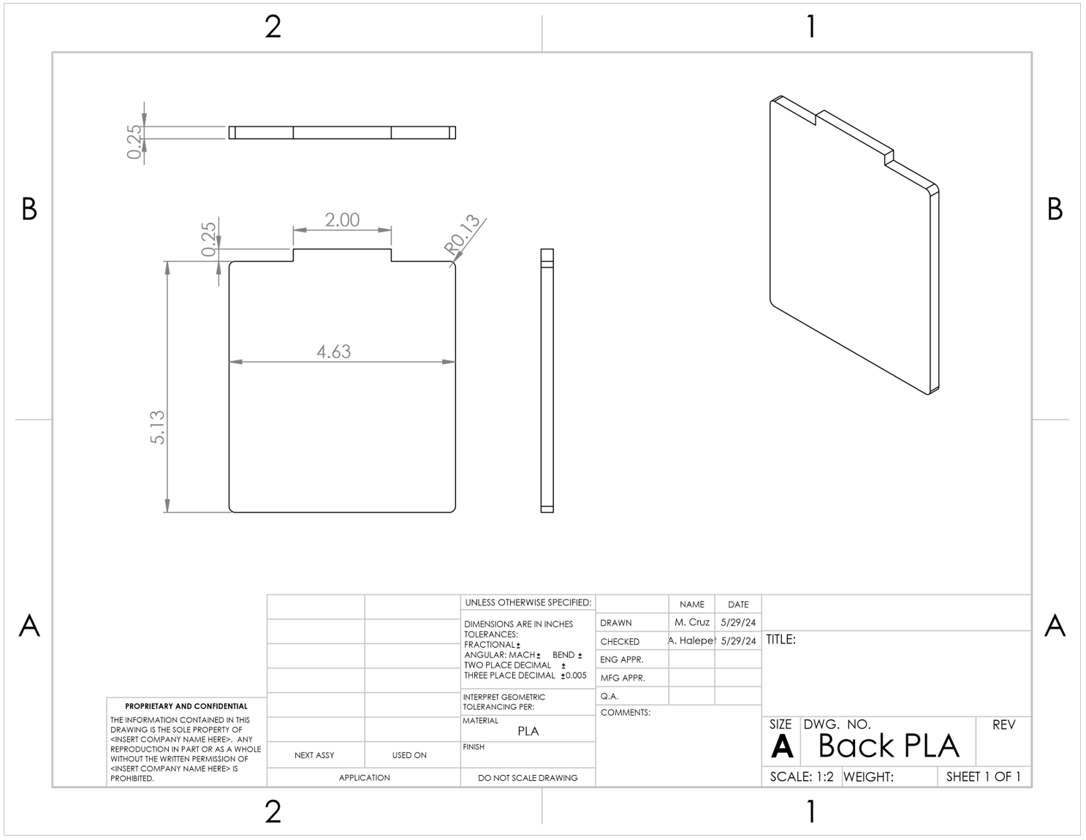

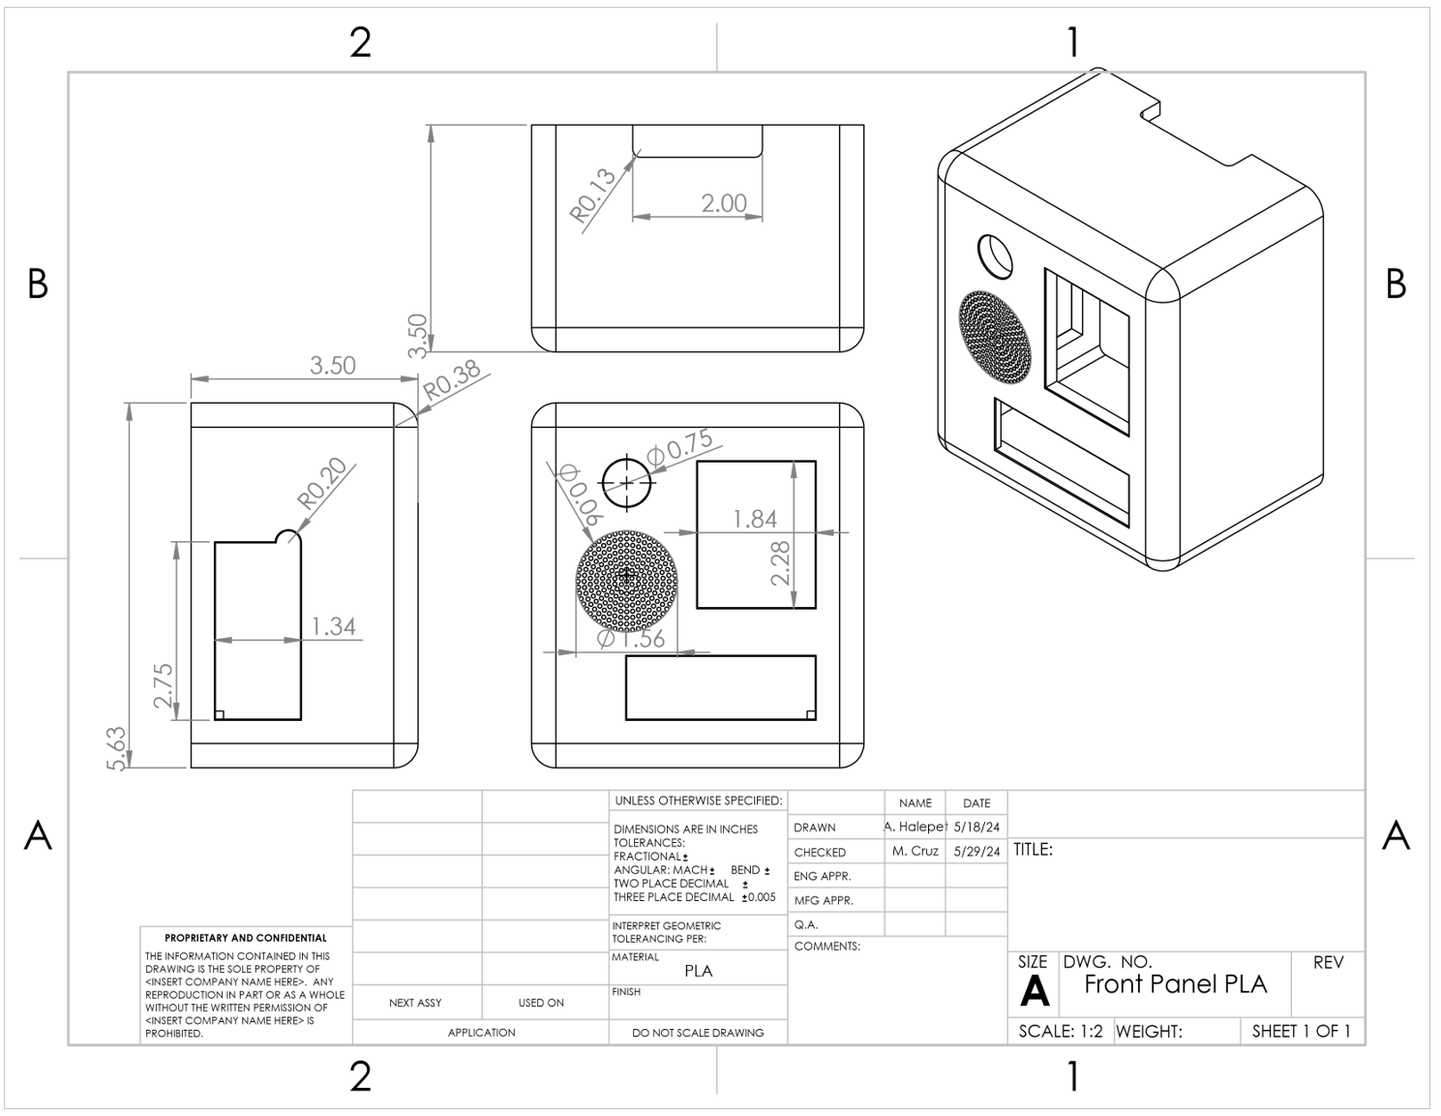

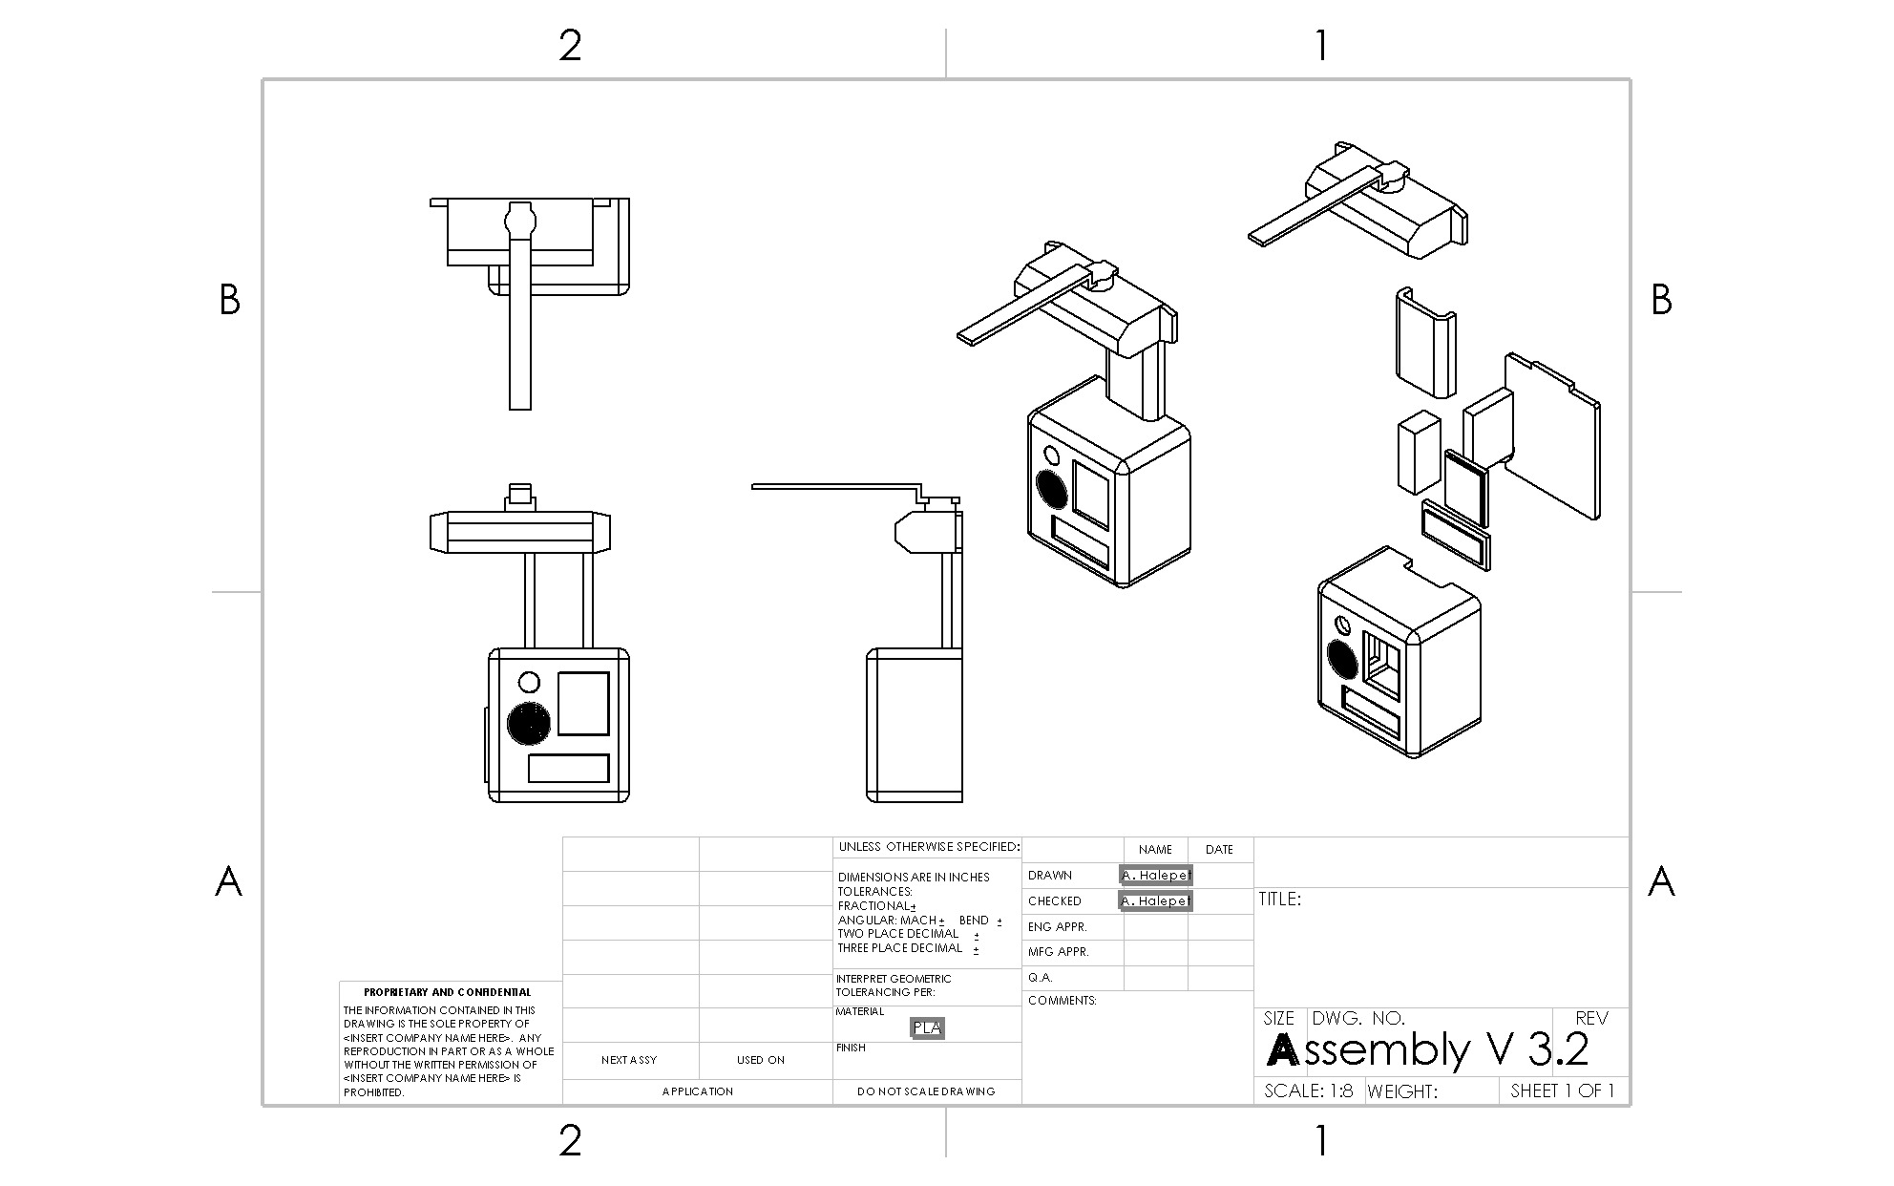

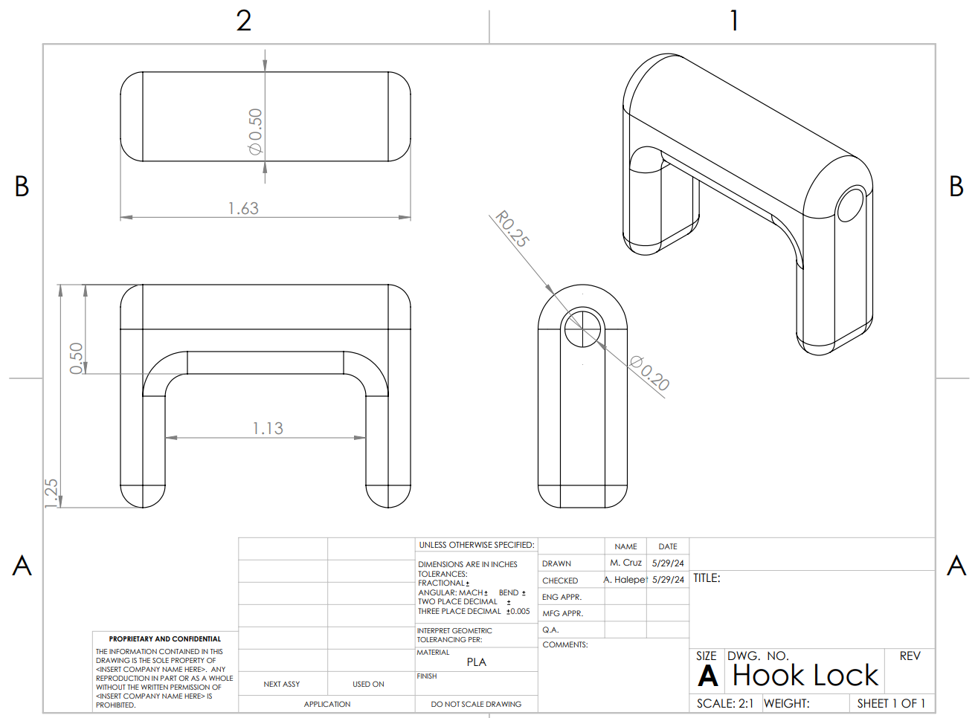

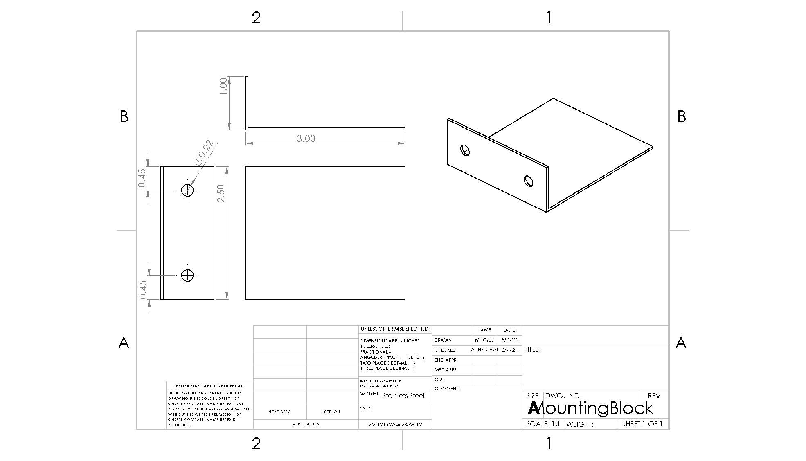

Figure 14: Circuitry Wiring Diagram

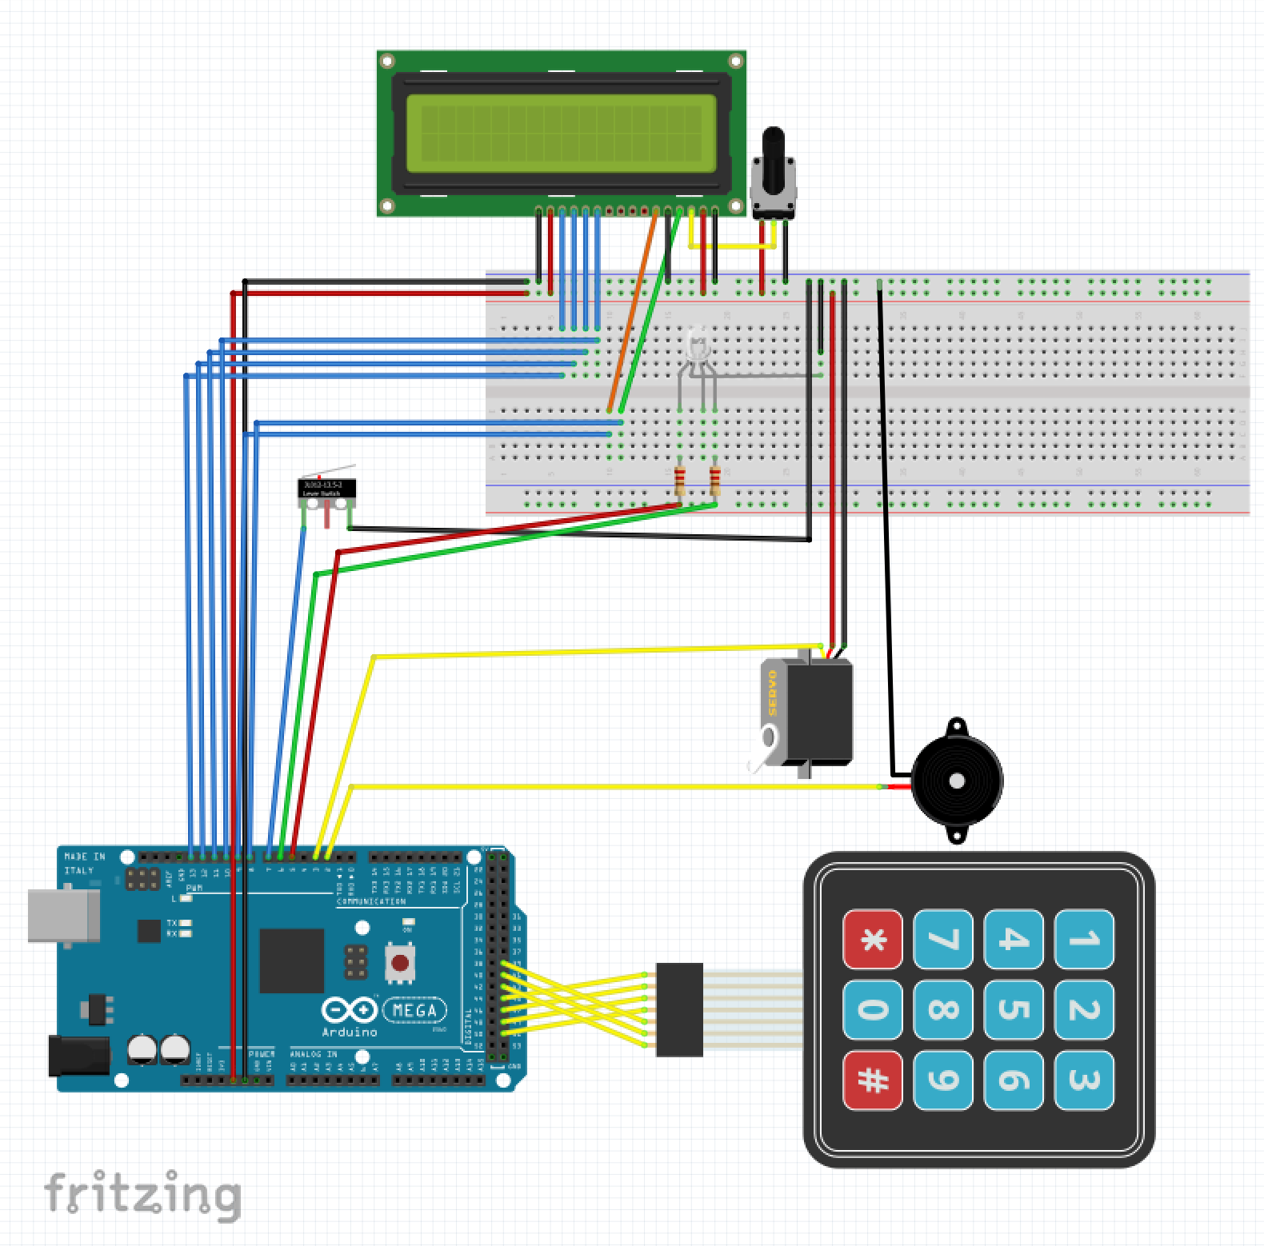

# **References**

# 

[1] “Fisherbrand Isotemp General-Purpose Freezers - Cold Storage Products, Freezers.” Accessed: Jun. 05, 2024. [Online]. Available:<https://www.fishersci.com/shop/products/fisher-scientific-isotemp-general-purpose-freezers/13986148>

[2] “Fisherbrand Isotemp General Purpose Laboratory Freezers - Cold Storage Products, Freezers.” Accessed: Jun. 05, 2024. [Online]. Available:<https://www.fishersci.com/shop/products/isotemp-general-purpose-laboratory-freezers/FBG25FSSA>

[3] “Freezer Failure In The Lab | eBook,” XiltriX. Accessed: Jun. 05, 2024. [Online]. Available:<https://xiltrixusa.com/freezer-failure-in-the-lab-ebook/>

[4] B. Pascus, “Children’s Hospital Los Angeles freezer failure leads to stem cell loss for patients treated for cancer - CBS News.” Accessed: Jun. 05, 2024. [Online]. Available:<https://www.cbsnews.com/news/childrens-hospital-los-angeles-freezer-failure-stem-cells-destroyed-2019-09-26/>

[5] T. Rakow, S. El Deeb, T. Hahne, D. A. El‐Hady, H. M. AlBishri, and H. Wätzig, “Investigating effects of sample pretreatment on protein stability using size‐exclusion chromatography and high‐resolution continuum source atomic absorption spectrometry,” Journal of Separation Science, vol. 37, no. 18. Wiley, pp. 2583–2590, Aug. 2014. doi: 10.1002/jssc.201400189

[6] “VFC | Current CDC Vaccine Price List | CDC.” Accessed: Jun. 05, 2024. [Online]. Available:<https://www.cdc.gov/vaccines/programs/vfc/awardees/vaccine-management/price-list/index.html>

[7] M. R. Holm and G. A. Poland, “Critical aspects of packaging, storage, preparation, and administration of mRNA and adenovirus-vectored COVID-19 vaccines for optimal efficacy,” *Vaccine*, vol. 39, no. 3, pp. 457–459, Jan. 2021, doi: [10.1016/j.vaccine.2020.12.017](https://doi.org/10.1016/j.vaccine.2020.12.017).

[8] “Ultra Low Temperature Freezer Maintenance | Sustainable Stanford.” Accessed: Jun. 05, 2024. [Online]. Available:<https://sustainable.stanford.edu/operations/buildings-grounds/labs/programs-rebates/ultra-low-temperature-freezer-maintenance>

[9] “Laboratory Freezers | Fisher Scientific.” Accessed: Jun. 05, 2024. [Online]. Available:<https://www.fishersci.com/us/en/browse/90106025/laboratory-freezers>

[10] “Safe & Effective Freezer Storage | Office of Research.” Accessed: Jun. 05, 2024. [Online]. Available:<https://www.bu.edu/research/ethics-compliance/safety/laboratory-safety/safe-effective-freezer-storage/>

[11] “When Freezers Fail,” Clinical Lab. Accessed: Jun. 05, 2024. [Online]. Available:<https://www.clinicallab.com/when-freezers-fail-22013>

[12] “Recognized Consensus Standards: Medical Devices.” Accessed: Jun. 05, 2024. [Online]. Available:<https://www.accessdata.fda.gov/scripts/cdrh/cfdocs/cfstandards/detail.cfm?standard__identification_no=32330>

[13] “Ergonomic guidelines for manual material handling.,” NIOSH. Jul. 2020, doi:[10.26616/NIOSHPUB2007131](https://doi.org/10.26616/NIOSHPUB2007131).

# 

# **Appendix**

# 

## Figure 15: Exploded View of the Biorefrigerator Security System

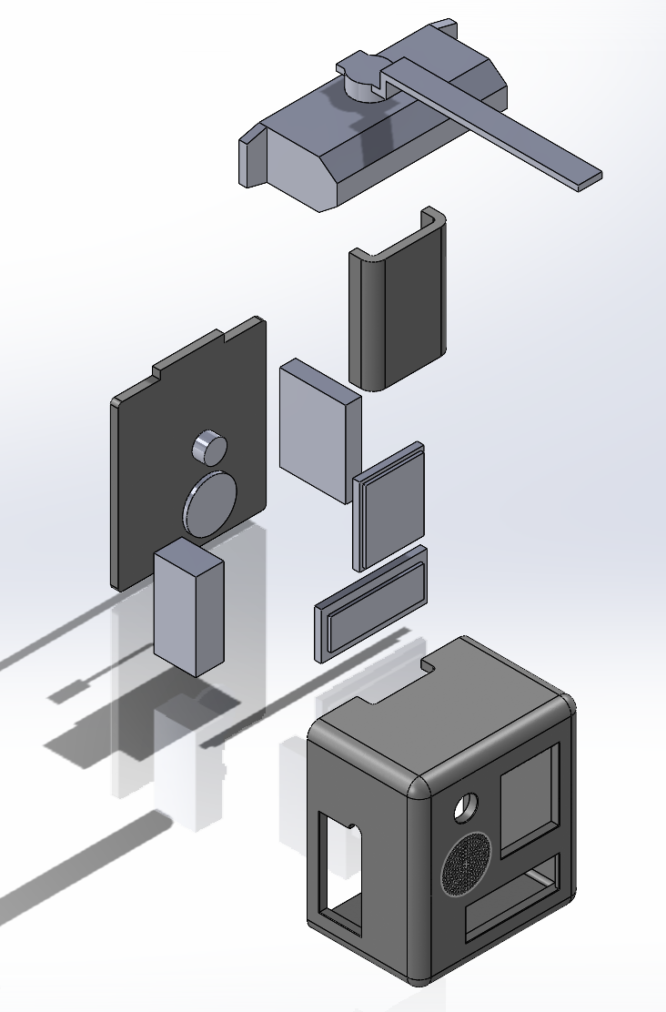

## Figure 16: House of Quality

## 

## 

**Table 8: Design Process Bill of Materials**

| **Component** | **Material** | **Purchasing Location** | **Part Number** | **Quantity** | **Weight** | **Price Per Purchase** | **Total Price** | **Notes** | **Link** |
| --- | --- | --- | --- | --- | --- | --- | --- | --- | --- |
| Case | PLA | UC Davis | N/A | Per kg | ~1/2 kg | $30 per kg | $15 |  |  |
| Screws | 18-8 Stainless Steel | McMaster-Carr | 92010A216 | 1 pack | ~0 | $7.01 | $7.01 | For the Body attachment. 100 Pack | [Screws](https://www.mcmaster.com/92010A216/) |
| 6061 Aluminum | 6061 Aluminum | Amazon | N/A | 3 | 1.755 lbs per sheet | $18.99 | $56.97 | The body for the pin pad | [6061 Aluminum Component Link](https://www.amazon.com/Aluminium-Aluminum-Finely-Polished-Deburred/dp/B08M63VD66/ref=asc_df_B08M63VD66/?tag=hyprod-20&linkCode=df0&hvadid=507685853899&hvpos=&hvnetw=g&hvrand=13803444464249626083&hvpone=&hvptwo=&hvqmt=&hvdev=c&hvdvcmdl=&hvlocint=&hvlocphy=1013763&hvtargid=pla-1244865546405&psc=1&mcid=73ecb0c2c16c363090a3ab1a556c41a9&gclid=CjwKCAiAqY6tBhAtEiwAHeRopVNa8dwxIhKlyLCnpZvd1lSsjFA1dELC7lDzbDw5YA9n06tZS93lMhoC3QAQAvD_BwE) |
| Wires | PVC Coated Copper | Amazon | B08BBXTBL7 | 1 | 0.79 lbs total | $14.94 | $14.94 | Wiring for the device | [Wires](https://www.amazon.com/Gauge-Wire-Solid-Core-Hookup/dp/B08BBXTBL7/ref=sr_1_4?crid=2YFKFOA4RD63X&dib=eyJ2IjoiMSJ9.UIo5E3q7NzPjkxQwKGNfdQ3FuhAzLC-mAshupgLoSkDXkWJc1I1QggnkW8dAvnQAoPGPPllbJenMA18wVx0t9j-gmsoh0NwyJyPDq3IPxBP2T55pKQpW10vA9NtuKP_kZATr4Ul6AlKtvMASqldw9Q.xbG82dSqDf78ub71xgXVEjiEBb7RhIcGF8l26PJFpKs&dib_tag=se&keywords=wires&qid=1705265164&s=hi&sprefix=wire%2Ctools%2C199&sr=1-4) |
| Adhesive (Epoxy) | Epoxy Resin | Amazon | N/A | 1 | 0.125 lbs total | $12.45 | $12.45 | 2 pack, Metal Adhesive | [Epoxy Resin](https://www.amazon.com/J-B-Weld-Original-Reinforced-Strength/dp/B0B5VNG2YT/ref=asc_df_B0B5VNG2YT/?tag=hyprod-20&linkCode=df0&hvadid=598238944920&hvpos=&hvnetw=g&hvrand=16027891236110708106&hvpone=&hvptwo=&hvqmt=&hvdev=c&hvdvcmdl=&hvlocint=&hvlocphy=1013763&hvtargid=pla-1695224676408&mcid=13a156f4cdf13c26a20bfeb5266c44ce&gclid=CjwKCAiAqY6tBhAtEiwAHeRopf2Vh7qsXWIDqrsuZjqCuv6-VXtDVUysLzUv1R-RMKNJFESZMiPzWBoCWzAQAvD_BwE&th=1) |
| Closer | Aluminum | Amazon | ‎SOULONGg850ya231w | 1 | 2.31 lbs | $20.81 | $20.81 | Will use for hydraulic components | [Closer Link](https://www.amazon.com/Aluminum-Commercial-Automatic-Closing-Independent/dp/B08GPD3W6V/ref=asc_df_B08GPD3W6V/?tag=hyprod-20&linkCode=df0&hvadid=680463214693&hvpos=&hvnetw=g&hvrand=18051584580321407561&hvpone=&hvptwo=&hvqmt=&hvdev=c&hvdvcmdl=&hvlocint=&hvlocphy=1013721&hvtargid=pla-2260095885309&psc=1&mcid=624b2ed7d3513a4e9b84fd5e8e249870) |
| Limit Switch | metal and plastic | Amazon | V-156-1C25 | 10 | Not Available | $1.00 | $9.99 | Possible to use in place of potentiometer, will test | [Limit Switch](https://a.co/d/gz5lPw8) |
| Battery | 9V battery | Amazon | N/A | 1 pack of 4 | 0.05lbs | $9.55 | $9.55 | Power source for device | [9V battery](https://www.amazon.com/Amazon-Basics-Performance-All-Purpose-Batteries/dp/B0774D64LT?th=1) |
| 18 Gauge Steel Sheet | Mild Steel | Amazon | B08GFXMXNG | 2 packs of 2 | 2.84 lbs per sheet | $29.90 | $59.80 | Alternative Body for case | <https://a.co/d/a3CqhTq> |
| Adafruit METRO | Microcontroller | Adafruit | 3505 | 1 | 0.042 lbs | $17.50 | 17.50$ | Coding component for alarms, pin pad, potentiometer | [Adafruit METRO](https://www.adafruit.com/product/3505) |
| Red and Green Indicator LED | LED | Adafruit | 4042 | 1 | Not Available | $1.75 | $1.75 | Light Alarm | [RED/GREEN LED Link](https://www.adafruit.com/product/4042) |
| Pin Pad | N/A | Adafruit | 3845 | 2 | ~0 | $6.50 | $13.00 | The pin pad itself | [Pin Pad Link](https://www.adafruit.com/product/3845) |
| Potentiometer | metal | Adafruit | 562 | 1 | Not Available | $0.95 | $0.95 | 10k kiloohms | [Potentiometer](https://www.adafruit.com/product/562) |
| Speaker | N/A | Adafruit | 1891 | 2 | 0.01 lbs | $1.75 | $3.50 | Speaker for the alarm | [Speaker](https://www.adafruit.com/product/1891) |
| Resistor | 10kΩ 5% | Adafruit | 2784 | 2 | ~0 | $0.75 | $1.50 | For voltage divider | [10kΩ resistor](https://www.adafruit.com/product/2784) |
| Battery Holder |  | Adafruit | 67 | 2 | 0.05lbs | $3.95 | $7.90 |  | <https://www.adafruit.com/product/67> |
| Servo | Micro Servo | Adafruit | 2307 | 2 | 0.03lbs | $11.95 | $23.90 |  | [Servo](https://www.adafruit.com/product/2307) |
| Metro ESP32-S3 | Microcontroller | Adafruit | 5500 | 1 |  | $24.95 | $24.95 |  | [Metro ESP32-S3](https://www.adafruit.com/product/5500) |
| LCD Backlight | LCD Display | Adafruit | 181 | 2 | Neglible | $9.95 | $19.90 | Possible HUD | <https://www.adafruit.com/product/181> |
| Female/Male Jumper Wire | Silicone Covered | Adafruit | 1953 | 1 | ~0.03lbs | $1.95 | $1.95 | F/M Extension - 20 x 6" (150mm) | <https://www.adafruit.com/product/1954> |
| Male/Male Jumper Wire | Silicone Covered | Adafruit | 4482 | 1 | 0.03lbs | $1.95 | $1.95 | M/M Extension - 20 x 6" (150mm) | <https://adafruit.com/product/1957> |
| ELEGOO MEGA 2560 | Microcontroller | ELEGOO | N/A | 1 |  | $19.99 | $19.99 | Microntroller used in the prototype | [ELEGOO](https://www.elegoo.com/products/elegoo-mega-2560-r3-board) |
| 18 Gauge Steel Sheet | Mild Steel | Amazon | B08GFXMXNG | 1 | 1.42 lbs per sheet | $29.90 | $29.90 | Attachment Block | <https://a.co/d/a3CqhTq> |
| Self Tapping Screws | Stainless Steel | Amazon | 9015995 | 1 pack | ~0 | $6.90 | $6.90 | For component attachment. 25 Pack | [Screws](https://a.co/d/gUcn6Kk) |
| 6-32 Hex Nuts | Zinc Plated Steel | Home Depot | 802131 | 6 | ~0 | $1.38 | $1.38 |  | [Hex Nuts](https://www.homedepot.com/p/Everbilt-6-32-Zinc-Plated-Machine-Screw-Nut-12-Pack-802131/204274121?source=shoppingads&locale=en-US&pla&mtc=SHOPPING-BF-CDP-GGL-D25H-025_003_FASTENERS-NA-NA-NA-PMAX-NA-NA-NA-NA-NBR-NA-NA-NA-Fasteners&cm_mmc=SHOPPING-BF-CDP-GGL-D25H-025_003_FASTENERS-NA-NA-NA-PMAX-NA-NA-NA-NA-NBR-NA-NA-NA-Fasteners-71700000113162680--&gad_source=1&gclid=CjwKCAjwjeuyBhBuEiwAJ3vuoX1yZx6K0lHu4Y4T7nSHWEFcBklySLooaQUgLEBejZmTFEd1JWgA2xoCkjYQAvD_BwE&gclsrc=aw.ds) |
| Mini Breadboard | Plastic | Amazon | EK2137 | 2 | 0.01 lbs | $8 | $8.00 |  | [Mini Breadboard](https://www.amazon.com/dp/B0146MGBWI?ref=cm_sw_r_apan_dp_6XY93ZM82QF5STMMKEZG_1&ref_=cm_sw_r_apan_dp_6XY93ZM82QF5STMMKEZG_1&social_share=cm_sw_r_apan_dp_6XY93ZM82QF5STMMKEZG_1&starsLeft=1) |
| Sum of Prices |  |  |  |  |  |  | $391.44 |  |  |

## Table 8: Complete Failure Modes and Effects Analysis

| Item | Potential Failure Mode | Potential Causes | O | Potential Effect | S | Current Controls | D | RPN (S x O x D) | Migration Strategy/ Actions Recommended |
| --- | --- | --- | --- | --- | --- | --- | --- | --- | --- |
| Alarm | False Negative on speaker | (i) The speaker itself may be damaged  (ii) The limit switch is damaged  (iii) Loose connections  (iv) wiring damage | 1 | The audio alarm will not sound making it difficult to know if the lab door is left open. | 8 | When the device is being assembled, check functionality of the speaker, limit switch, and wire connections. | 6 | 60 | Establish monthly routine check-ups. Ensure verification of the completed system (ex: A door open for too long causes Speaker and LED alarm to activate) |
|  | False Negative on LED | (i) The LED itself may be damaged  (ii) The limit switch is damaged  (iii) Loose connections  (iv) wiring damage | 1 | The LED alarm will not light, making it difficult to know if the CLE door is left open | 8 | When the device is being assembled, check functionality of the LED, limit switch, and wire connections. | 6 | 60 | See above |
|  | False Positive on speaker | (i) The limit switch may be stuck  (ii) crossed wires | 4 | The sound will be audible and the user thinks the door is open when it is still closed. | 3 | Check wire connections during assembly. Design the case with ample wiring space and include cable routing brackets. | 1 | 12 | See above |
|  | False Positive on LED | (i) The limit switch may be stuck  (ii) crossed wires | 4 | The light will turn on making nearby users believe the door is open when it is not | 3 | Check wire connections during assembly. Design the case with ample wiring space and include cable routing brackets. | 1 | 12 | See above |
| Security | Accepts incorrect PIN code | (i)Software malfunction (ii)crossed wires may change the received passcode from the one input | 1 | The CLE could be unlocked when not supposed to. | 5 | Thoroughly test the PIN pad circuit during verification. Check wire connections during assembly. Design the case with ample wiring space and include cable routing brackets. | 6 | 30 | Provide circuit diagram and review and fix as needed.  Wipe previous passcode data, Reinput new passcode |
|  | Rejects correct PIN code | See above | 1 | The CLE could be not unlockable. | 3 | Thoroughly test the PIN pad circuit during verification. Check wire connections during assembly. Design the case with ample wiring space and include cable routing brackets. | 1 | 3 | See above |
|  | Servo does not rotate all the way | (i)Buildup of debris may limit the range of motion of the servo  (ii) Manufacturing error | 4 | The lock will not properly open or close at the specific angle it should, resulting in difficulty in opening the CLE doors and/or damage to the servo and hook assembly | 6 | Test the servo during validation. Design the servo mount with enough space to clean the servo if needed | 2 | 48 | Replace or provide instructions for maintenance of the component. Pressurized air or a cloth may be used to clear debris in the gaps |
| Pressurized Door Closer | Door does not close all the way | (i)Insufficient closing pressure  (ii) physical obstruction of the CLE door | 1 | The door could be left open, which can negatively impact samples in the CLE. | 1 | The closer is equipped with values to change closer pressure. The alarms are coded to sound after the doors are open for a specified length of time in case of physical obstruction | 4 | 40 | See above |
|  | Excessive closing pressure | (i) improperly tuned sweep speed  (ii) improperly tuned latch speed | 2 | The CLE door could be slammed shut, jostling the contents inside. | 4 | The closer is equipped with values to change closer pressure | 2 | 16 | See above |
| Epoxy | Failure to stick to the intended CLE | (i) manufacturing defect  (ii) Not allowing for the full curing time  (iii) insufficient adhesive coverage  (iv) unclean application surface | 3 | The lock could fall off, meaning that the lock cannot be used properly. | 8 | Device adhesion surfaces are designed with large surface areas | 1 | 24 | Ensure that when applying export, appropriate time and amount must be given to the epoxy before use |
|  | Sticks to user during assembly | (i) touching the epoxy resin during installation | 5 | The sticking could be hard for the user to remove from themselves. | 4 | None | 1 | 20 | Ensure that when applying epoxy, appropriate protection is used to prevent the epoxy from sticking on the user. |
|  | Inhalation of epoxy fumes | (i) poor ventilation during assembly | 5 | Skin, eyes, nose, and throat irritation. Possible trigger for skin allergies and asthma | 5 | None | 2 | 50 | Ensure that when applying epoxy, application is done where it is well ventilated or provide masks as needed. |
| Electrical | Short Circuit | (i) Water damage  (ii) Faulty wiring  (iii) Loose connections  (iv) Overheating | 3 | The circuitry for the whole device would not function, resulting in possible lock failure. | 8 | Check wiring during verification and assembly. Designed with space between components to improve air flow | 6 | 144 | Disassemble the PIN Pad casing and assess the current state of the internal components. Ensure complete connections. Replacement of damaged components may be necessary based on the severity of the damage. |
| Structural | Rust | (i) Exposure to moisture  (ii) Exposure to acids  (iii) Contact with dissimilar metals | 2 | The lock could potentially degrade over time due to rust, potentially with a small risk of loss of the function of moving parts such as the servo, arms, or rack and pinion system. | 3 | Check the assembled device for any gaps. Device was designed to be positioned away from any possible spills | 2 | 12 | Proper controls are deemed sufficient |
|  | Material Wear | (i) friction | 3 | Degradation over time due to friction, potentially with a small risk of loss of the function of moving parts such as the servo, arms, or rack and pinion system. | 3 | Device was built with tough materials to withstand many use cycles, and will be smooth to reduce friction | 2 | 18 | Proper controls are deemed sufficient |
|  | Epoxy Buildup/residue | (i)excessive adhesive usage  (ii)drip during installation | 4 | Uncured epoxy resin may cause skin irritation, respiratory issues and may be flammable. Cured epoxy resin will only pose aesthetic issues | 2 | None | 2 | 16 | Ensure that instructions provided to the user tell them to use an appropriate amount of epoxy. Otherwise, give instructions to use epoxy remover |
|  | Moisture Damage | (i) condensation from the CLE  (ii) Liquid spills | 4 | Rust and damage to electrical components | 6 | Check the assembled device for any gaps. Device was designed to be positioned away from any possible spills | 6 | 144 | If there is any moisture, check the immediate area and also if there are any gaps in the device as well as check inside the CLE and fix the problem immediately. |
|  | Thermal Expansion | (i) heating from the electrical components  (ii) heating from the CLE | 2 | Expansion of materials and components may reduce the available space and lead to crowding. | 2 | Check wiring during verification and assembly. Designed with space between components to improve air flow | 6 | 24 | Check the temperatures in the electrical components and CLE and if it's not cold enough, adjust the temperature. |
| Battery | Exposure to moisture | (i) condensation from the CLE  (ii) Liquid spills | 4 | A battery with moisture would have its function impaired due to reduced resistance | 7 | Check the assembled device for any gaps. Device was designed to be positioned away from any possible spills | 4 | 112 | Remind the user that the device must be placed away from moisture and in a clean and dry area before applying |
|  | Overheating | (i) heating from the electrical components  (ii) heating from the CLE  (iii) Faulty wiring | 2 | A battery that is too hot will not function properly | 6 | Check wiring during verification and assembly. Designed with space between components to improve air flow | 6 | 72 | Disassemble the PIN Pad casing and assess the current state of the internal components. Ensure complete connections. Replacement of damaged components may be necessary based on the severity of the damage. |
|  | Battery dies | (i) Extended use | 2 | The lock will not work because there is no battery power. | 8 | None | 1 | 16 | Keep a stock of 9V batteries. Replace at appropriate/said times on the battery box |
|  | Acid Leak | (i) Physical damage to the battery  (ii) Extreme temperatures  (iii) Age | 2 | Corrosion of components and structural materials may occur. Users may also experience skin burns, inhalation irritation, and possible blindness if the acid come in contact with the eyes | 6 | None | 4 | 48 | Ensure that the batteries can be easily replaced every so often to ensure that there is no acid leak because of old and damaged batteries. Make the battery replacement user friendly and not complicated. |
| User | PIN Code is forgotten | (i) User forgets PIN code | 5 | The lock cannot be opened by this user | 2 | Master passcode will be provided to administrator, and will be included on documentation | 1 | 10 | Full system reset of the device. |
|  | Door is forced open when locked | (i) User ignores resistance of the hook mechanism  (ii) hook mechanism malfunction | 2 | If the door is opened when locked, then damage to the servo, hook, and arms is possible. | 6 | Alarms are in place to prevent this, and the servo and hook assembly provides resistance to opening when the device status is “locked” | 2 | 24 | If there’s resistance to opening, check if the LED is green |
| Manufacturing | Loose device structural connections | (i) Loose screws  (ii) Improper tolerances | 4 | The lock structure could be unstable, which could prompt anywhere from the lock not functioning to the lock structure to break. | 5 | Manufacturing within standard tolerances, and ensuring properly tightened screws and connections during verification and assembly | 4 | 80 | Tighten loose connections with a screwdriver if applicable |
|  | Power does not transfer from the microcontroller | (i)Faulty wires  (ii)Damage to the microcontroller  (iii)Loose connections  (iv)Battery issues listed above | 2 | The lock will simply not function at all as it does not have the power needed. | 8 | Test battery and microcontroller during verification, check wiring during assembly | 3 | 48 | Disassemble the PIN Pad casing and assess the current state of the internal components. Ensure complete connections. Replacement of components may be necessary based on the cause. |

*A false positive means that the device reports the CLE as open when it is closed

*A false negative means that the device reports the CLE as closed when it is open